HDMI to HD-SDI CONVERTER
ITEM NO.: SDI02

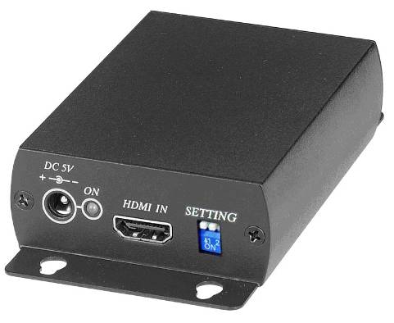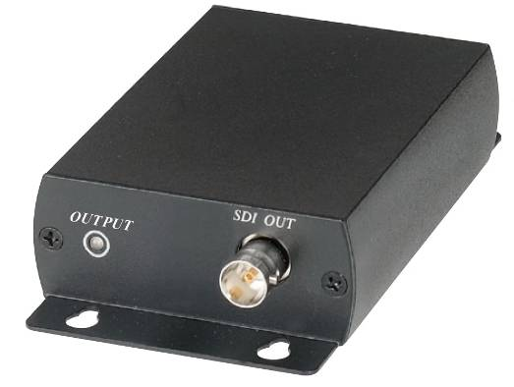

SDI02 converts signal from HDMI to 3G-SDI, HD-SDI and SD-SDI which provides the highest quality images for professional audio-visual end users. Designed as a high performance video processor for post-production and broadcast applications, the HDMI to SDI Converter provides exceptional and enhanced image processing and quality.

Features:
- To send HDMI signal converter to 3G/HD/SDI signal
- Support video signal 480i, 576i, 720p, 1080i, 1080p.
- Support SDI (SMTP 259M), HD-SDI (SMTP 292M), 3G-SDI (SMTP 424M).
- Support audio LPCM 7.1 Channel.

Installation:

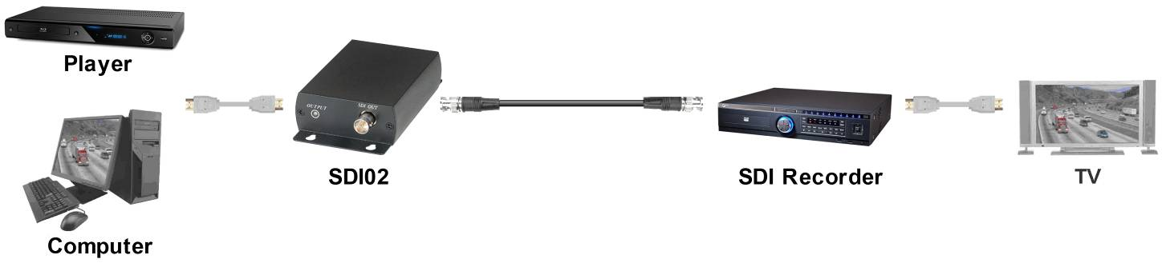

Panel View:

SDI02

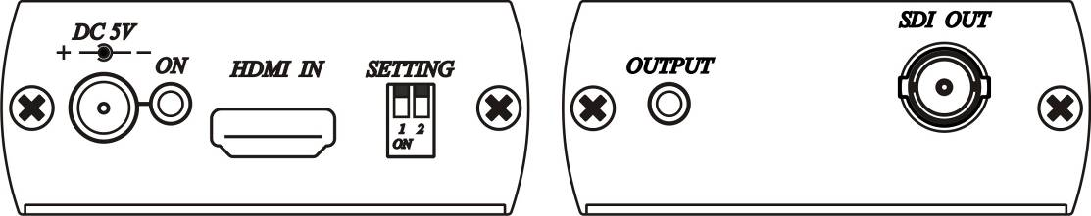

Recommend Cable:

To send HD video must use coaxial cable with Bandwidth at least 1.5G , to send Full HD video must use coaxial cable with bandwidth at least 3G.

Link cable recommend to use high quality 75Ω Coaxial Cable & BNC connector , to use low quality coaxial cable may case signal loss and effect transmission distance and reliability.

Working Distance:

Max. distance via high quality 75Ω Coaxial Cable ( Belden 1505A Testing)
SD (480i,576i resolution) (270Mbps) | 300M
HD (720p, 1080i, 1080p@24/25/30Hz resolution) (1.45Gbps) | 200M
Full HD (1080p@50/60Hz) resolution (2.97Gbps) | 100M

LED Indication:

GREEN Power & Signal
ON Power on
FLASH Not support HDMI input format

BLUE SDI signal
ON SDI signal output

Switch Instruction:

1 ↑ Video Support 480i, 576i, 720p@50/59.94/60Hz, 1080i@50/59.94/60Hz.
↓ Video Support 480i, 576i, 720p@50/59.94/60Hz, 1080i@50/59.94/60Hz,
1080p@23.98/24/29.97/30/50/59.94/60Hz.

2 ↑ Audio Support LPCM 2 Channels.
↓ Audio Support LPCM 8 Channels.

Trouble Shooting:

1. SDI signal not support HDMI 480p & 576p resolution.
2. SDI output resolution and frequency is same as HDMI input, if your SDI monitor not support HDMI
input resolution and frequency, then it won’t have picture at the monitor.

Specification:

ITEM NO. | SDI02
SDI Standard / Protocol | SDI (SMTP 259M), HD-SDI (SMTP 292M), 3G-SDI (SMTP 424M)
Resolution | NTSC (480i), PAL (576i),  720p@50/59.94/60Hz,  1080i@50/59.94/60Hz,  1080p@23.98/24/29.97/30/50/59.94/60Hz
Audio | LPCM 8 Channels, 48Khz, 16 / 20 / 24Bit
HDMI Output Connector | HDMI Type A
SDI Output Connector | BNC 75Ω
Power Consumption | 850mA (Max)
Power Supply | Switching DC5V 1AMP
Temperature | Operation: 0 to 55℃, Storage: -20 to 85℃, Humidity: up to 95%
Dimensions | 67 x 110 x 27 (mm)
Weight | 200 g

Rev. B

