HD-SDI TO HDMI CONVERTER
ITEM NO.: SDI01

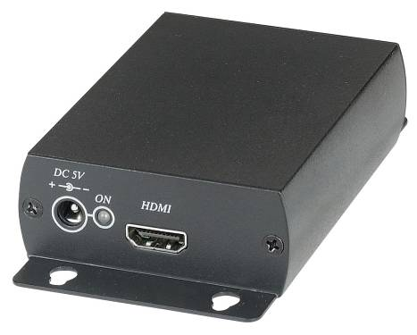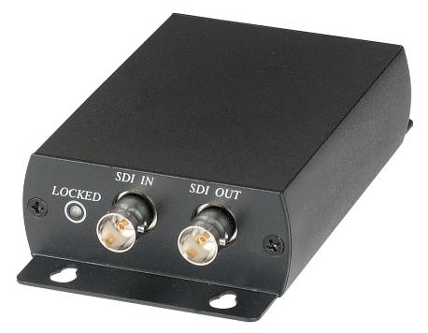

SDI01 converts from 3G-SDI, HD-SDI and SD-SDI to HDMI which enabling users to use cost effective HDMI display to SDI based equipment. It also provides 2 channel stereo audio. The application could be using for HD CCTV HD-SDI camera and broadcast video monitoring.

Features:
- To send 3G/HD/SDI signal convert to HDMI.
- Support SDI (SMTP 259M), HD-SDI (SMTP 292M), 3G-SDI (SMTP 424M).
- Support video signal NTSC, PAL, 720p, 1080i, 1080p.
- Support HDMI 7.1 Channel audio.
- Built in Equalizer to increase the working distance and signal reliability.
- SDI Loop Out with Retiming function to have the best output quality.

Installation:

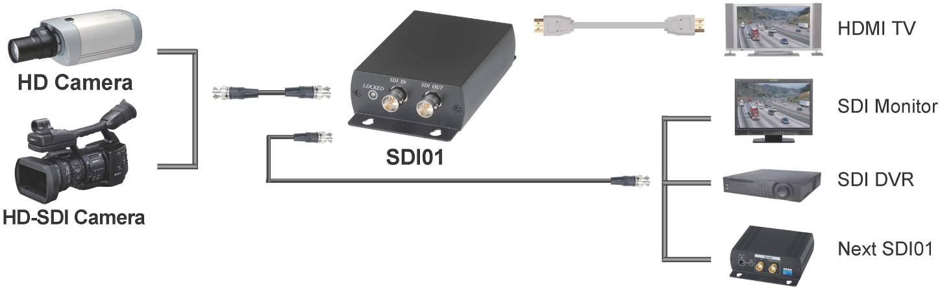

Recommend Cable:

Link cable recommend to use high quality 75Ω Coaxial Cable, low quality coaxial cable may case signal loss and effect transmission distance and reliability.

Working Distance:

Max. distance via high quality 75Ω Coaxial Cable ( Belden 1694A RG6U Testing)
SD resolution (270Mbps) | 300M
HD resolution (1.45Gbps) | 200M
Full HD resolution (2.97Gbps) | 100M

LED Indication:

GREEN Power
BLUE SDI signal lock

Panel View:

SDI01

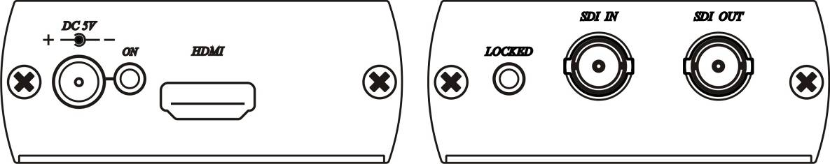

Trouble Shooting:

SDI01: HDMI output resolution and frequency is same as SDI input, if your TV monitor not support SDI input resolution and frequency, then it won’t have picture at the monitor..
For example: Under HD-SDI camera application, if your TV monitor not support 1080p@25Hz or 1080p@30Hz, then the monitor won’t display.
Please adjust your HD-SDI camera output resolution to 1080i or 720p.

Specification:

ITEM NO. | SDI01
SDI Standard / Protocol | SDI (SMTP 259M), HD-SDI (SMTP 292M), 3G-SDI (SMTP 424M)
Resolution | NTSC (480i), PAL (576i),  720p@50/59.94/60Hz,  1080i@50/59.94/60Hz,  1080p@23.98/24/29.97/30/50/59.94/60Hz
SDI Input Connector | BNC 75Ω
SDI Output Connector | BNC 75Ω
HDMI Output Connector | HDMI Type A
Power Consumption | 750mA (Max)
Power Supply | Switching DC5V 1AMP
Temperature | Operation: 0 to 55℃, Storage: -20 to 85℃, Humidity: up to 95%
Dimensions | 67 x 110 x 27 (mm)
Weight | 200 g

Rev. B

