4x4 Seamless Multiviewer/Matrix/Videowall
ITEM NO.: HM44
HM44 4x4 HDMI Seamless Matrix is the perfect solution for displaying content from up to four sources on four HDTV displays. Each of the sources can be individually scaled. Seamless switching ensures no frame loss during picture transitions. Eight preset buttons allow the user to store and recall custom-configured routing presets. Build in OSD menu simplifies system configuration. The HM44 HDMI Seamless Matrix is a great solution for small and large commercial venues that require content from four sources displayed on four displays instantly and without any loss of picture.

HM44 4x4 Seamless Multiviewer/Matrix/Videowall
- Input and Output resolutions up to 1080p Full HD and 1920x1200 (WUXGA)
- Support LPCM7.1 @ 192KHz, Dolby True HD, DTS-HD MA
- HDMI1.3, DVI1.0, and HDCP 1.4 compliant
- Video-Wall mode supports 2 x 2 Video-Wall with 4 selectable input sources
- Support 4 input and 4 multiview windows seamless switching
- Multiview mode support scales and sizes each picture.
- Multiview mode support PIP, POP and set PIP priority
- Support panel button, IR remote, RS232, Web GUI and APP control
- Support OSD menu setting
- Field-upgradable firmware for both web server and RS232.

Application View:

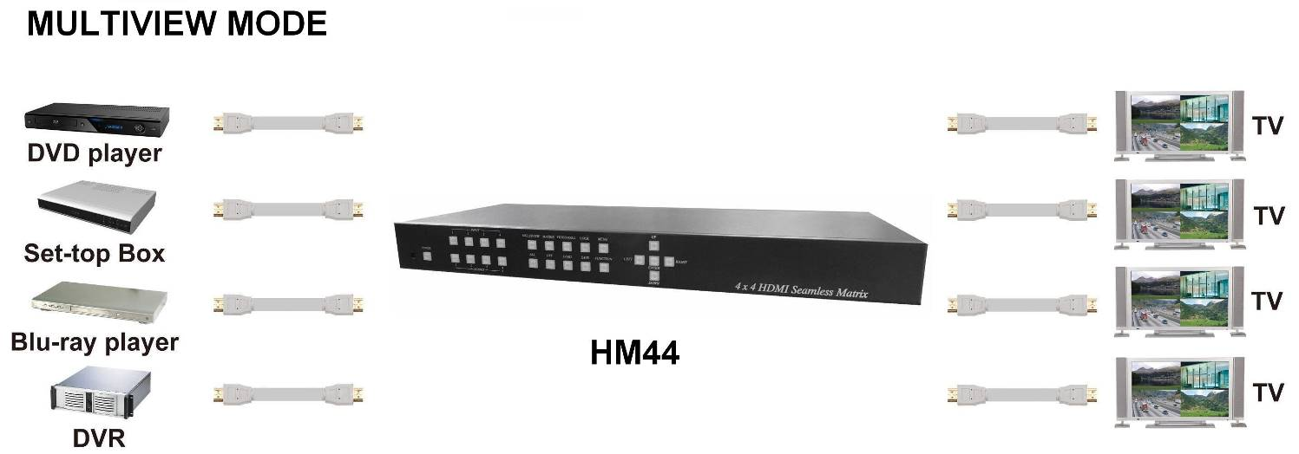

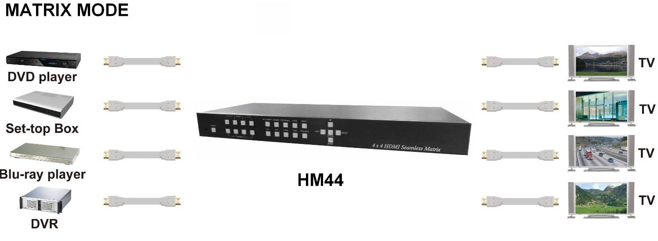

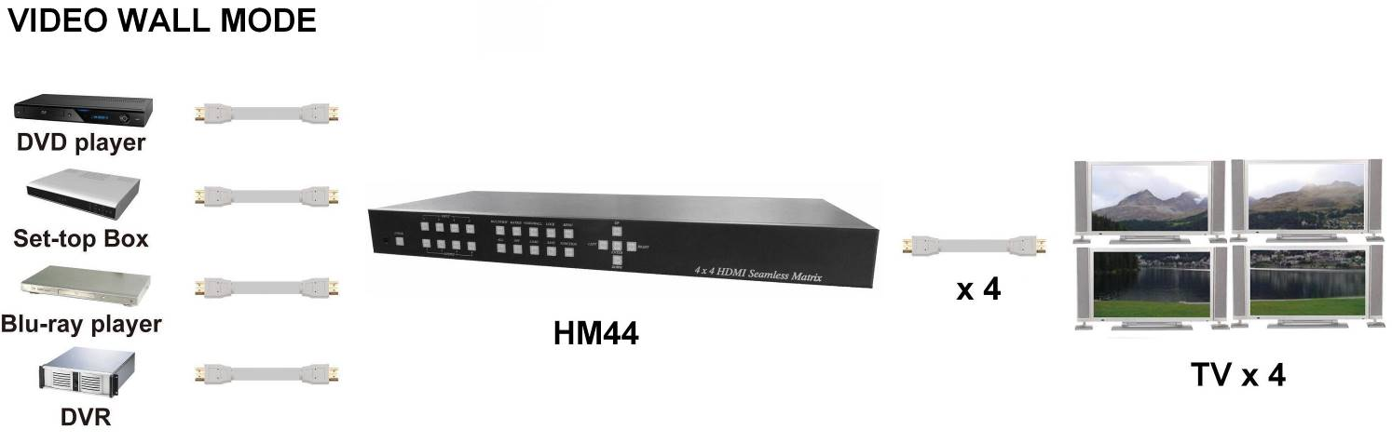

Panel View ：
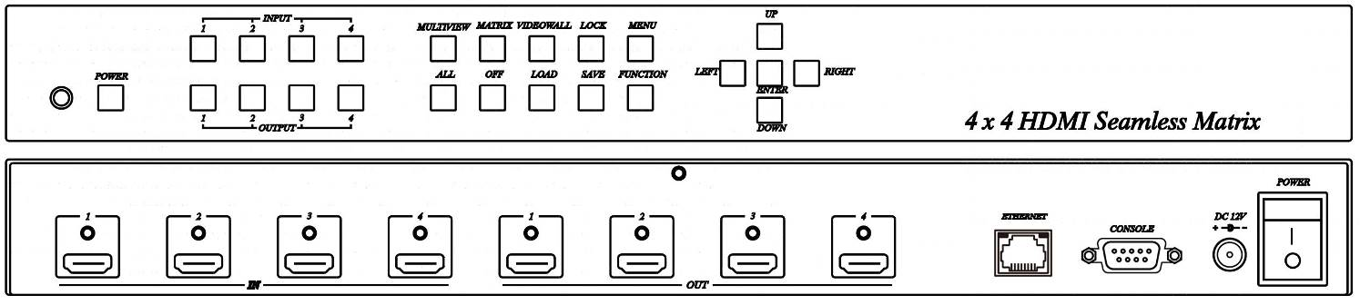

Front Panel Function:
1
3
6
5

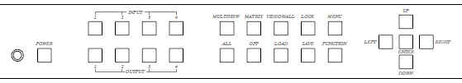

2
4

Panel Button Function:
No. | Function Name | Description
1 | IR | Receiving IR remote signal
2 | POWER | Power on / standby
3 | INPUT 1~4 | Press these buttons to select the desired input
4 | OUTPUT 1~4 | Press these buttons to select the desired output (not available for videowall mode)
5 | MULTIVIEW | Enter Multiview mode (All output display same screen)
5 | MATRIX | Enter Matrix mode
5 | VIDEOWALL | Enter videowall mode
5 | LOCK | Use this button to lock / unlock panel button and prevent accidental changes.
5 | MENU | - Enter OSD menu  - Back to upper level of menu
5 | ALL | Select all output (not available for videowall mode )
5 | OFF | Turn off the selected output (not available for videowall mode )
5 | LOAD | - Load layout/source in Multiview and Matrix mode from scene 1~8  - Load screen position in VIDEOWALL mode from scene 1~4
5 | SAVE | - Save current layout/source in Multiview and Matrix mode to scene 1~8  - Save screen position in VIDEOWALL mode to scene 2~4
5 | FUNCTION | - Switch different PIP/POP layout in Multiview Mode  - Bezel correction (adjust screen position) in VIDEOWALL MODE  - Not available in MATRIX MODE
6 | UP | - Move menu function up in OSD  - Move screen position up in videowall mode.
6 | DOWN | - Move menu function down in OSD  - Move screen position down in videowall mode.
6 | LEFT | - Move menu function left in OSD  - Move screen position left in videowall mode.
6 | RIGHT | - Move menu function right in OSD  - Move screen position right in videowall mode.
6 | ENTER | Execution selected function

Operating:
Multiview mode:
Output/input selection:
- Press OUTPUT 1~4 buttons to select the desired output windows (A~D), button LED will light on. You could select multiple outputs at the same time.
- Press INPUT 1~4 buttons to switch to desired input
- Press ENTER to quit the input selection.

Window layout selection:
- Press FUNCTION button to enter layout selection.
- Press INPUT /OUTPUT 1~4 to select desired layout, total 8 sets.
- Press ENTER to quit the layout selection.

Save scene:
- Press SAVE button.
- Press INPUT /OUTPUT 1~4 to save current windows layout and source of windows.
- Press ENTER to confirm.

Load scene:
- Press LOAD button.
- Press INPUT /OUTPUT 1~4 to load saved layout/source.
- Press ENTER to confirm.

Matrix mode:
Output/input selection:
- Press OUTPUT 1~4 buttons to select the desired output monitor, button LED will light on. You could select multiple OUTPUT at the same time.
- Press INPUT 1~4 buttons to switch to desired input
- Press ENTER to quit the input selection.

Save scene:
- Press SAVE button.
- Press INPUT /OUTPUT 1~4 to save current source of output.
- Press ENTER to confirm.

Load scene:
- Press LOAD button.
- Press INPUT /OUTPUT 1~4 to load saved output/source, total 8 sets.
- Press ENTER to confirm.

Videowall mode:
Input selection:
- Press INPUT 1~4 buttons to switch to desired input

Bezel correction:
- Press FUNCTION button.
- Press OUTPUT 1~4 to select the monitor to adjust screen position, shift depends on output resolution.
- Press INPUT 1~4 to select the monitor to adjust screen position, shift depends on input resolution.
- Press UP, DOWN, LEFT or RIGHT button to shift the screen.
- Press ENTER to quit the position adjustment.

Save scene:
- Press SAVE button.
- Press INPUT 2~4 to save current position of each screen.
- Press ENTER to confirm.

Load scene:
- Press LOAD button.
- Press INPUT 1~4 to load saved position of each screen(1 is factory default), total 4 sets.
- Press ENTER to confirm.

Rear Panel Function:

1
2
4
6

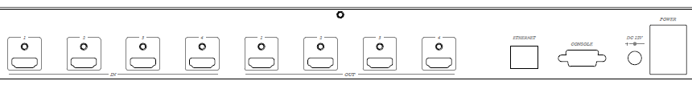
3
5

Panel Connector Function:
No. | Name | Description
1 | INPUT 1~4 | HDMI Input 1~4
2 | OUTPUT 1~4 | HDMI Output 1~4
3 | ETHERNET | Yellow LED: Link  Green LED: Data transmit/receive
3 | ETHERNET | WebGUI control / Web firmware update
4 | RS232 | RS232 control / firmware update
5 | DC12V | External power supply
6 | I/O | I: Power on  O: Power off

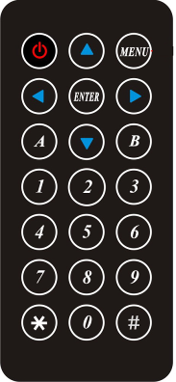
IR Remote Control (IR01) :
Initial at first time use the remote control or after change battery of remote control, the IR remote control and the equipment IR Remote ID must be using same. The default IR Remote ID is 0.

To setting the Remote ID, Press and hold power button, then press button 0 to complete the setting. +.(for example)

Remote Control Button Function:
Symbol | Function Name | Description
 | POWER | Power on / standby
 | UP | Move menu function up in OSD
 | DOWN | Move menu function down in OSD
 | LEFT | Move menu function left in OSD
 | RIGHT | Move menu function right in OSD
 | ENTER | Execution selected function
 | MENU | - Enter OSD menu  - Back to upper level of menu
 | Quick output/input selection | - Press to select output 1  - Switch to input 1 if output have been selected
 | Quick output/input selection | - Press to select output 2  - Switch to input 2 if output have been selected
 | Quick output/input selection | - Press to select output 3  - Switch to input 3 if output have been selected
 | Quick output/input selection | - Press to select output 4  - Switch to input 4 if output have been selected
 | Reserved
 | Reserved
 | Multiview | Switch to Multiview Mode
 | Matrix | Switch to Matrix mode
 | Videowall | Switch to Videowall mode
 | Turn off video | Turn off video if output have been selected
 | Reserved
 | Reserved
 | Reserved
 | Reserved

OSD MENU :
MAIN | SUB MENU | DESCRIPTION
SETUP | OUTPUT RESULTION | 480P 1366x768  576P 1440x900  720P50 1600x1200  720P60 1680x1050  1080P24 1920x1200  1080P50 BACK  1080P60, Default EXIT  1024x768  1280x800  1280x1024
SETUP | PICTURE SETTING | OUT SELECT | OUT1~OUT4, Default OUT1
SETUP | PICTURE SETTING | CONTRAST | 0~100, Default 50
SETUP | PICTURE SETTING | BRIGHTNESS | 0~100, Default 50
SETUP | PICTURE SETTING | SATURATION | 0~100, Default 50
SETUP | PICTURE SETTING | HUE | 0~100, Default 50
SETUP | PICTURE SETTING | RESET
SETUP | PICTURE SETTING | BACK
SETUP | PICTURE SETTING | EXIT
SETUP | OSD SETTING | MENU TIMEOUT | 0~100, Default 20
SETUP | OSD SETTING | INFO TIMEOUT | 0~100, Default 5
SETUP | OSD SETTING | INFO POSITION | RIGHT TOP
SETUP | OSD SETTING | INFO POSITION | LEFT TOP , Default
SETUP | OSD SETTING | INFO POSITION | RIGHT BUTTON
SETUP | OSD SETTING | INFO POSITION | LEFT BUTTON
SETUP | OSD SETTING | INFO DISPLAY | ON, OFF, Default ON
SETUP | OSD SETTING | BACK
SETUP | OSD SETTING | EXIT
SETUP | EDID | INPUT1 EDID | 1080P 2CH, Default
SETUP | EDID | INPUT1 EDID | 1080P MLT
SETUP | EDID | INPUT1 EDID | OUTPUT 1
SETUP | EDID | INPUT1 EDID | OUTPUT 2
SETUP | EDID | INPUT1 EDID | OUTPUT 3
SETUP | EDID | INPUT1 EDID | OUTPUT 4
SETUP | EDID | INPUT2 EDID | 1080P 2CH, Default
SETUP | EDID | INPUT2 EDID | 1080P MLT
SETUP | EDID | INPUT2 EDID | OUTPUT 1
SETUP | EDID | INPUT2 EDID | OUTPUT 2
SETUP | EDID | INPUT2 EDID | OUTPUT 3
SETUP | EDID | INPUT2 EDID | OUTPUT 4
SETUP | EDID | INPUT3 EDID | 1080P 2CH, Default
SETUP | EDID | INPUT3 EDID | 1080P MLT
SETUP | EDID | INPUT3 EDID | OUTPUT 1
SETUP | EDID | INPUT3 EDID | OUTPUT 2
SETUP | EDID | INPUT3 EDID | OUTPUT 3
SETUP | EDID | INPUT3 EDID | OUTPUT 4
SETUP | EDID | INPUT4 EDID | 1080P 2CH, Default
SETUP | EDID | INPUT4 EDID | 1080P MLT
SETUP | EDID | INPUT4 EDID | OUTPUT 1
SETUP | EDID | INPUT4 EDID | OUTPUT 2
SETUP | EDID | INPUT4 EDID | OUTPUT 3
SETUP | EDID | INPUT4 EDID | OUTPUT 4
SETUP | EDID | INPUT ALL | 1080P 2CH, Default
SETUP | EDID | INPUT ALL | 1080P MLT
SETUP | EDID | INPUT ALL | OUTPUT 1
SETUP | EDID | INPUT ALL | OUTPUT 2
SETUP | EDID | INPUT ALL | OUTPUT 3
SETUP | EDID | INPUT ALL | OUTPUT 4
SETUP | EDID | BACK
SETUP | EDID | EXIT
SETUP | HDCP | HDCP | FOLLOW INPUT, Default
SETUP | HDCP | HDCP | ALWAYS ON
SETUP | HDCP | BACK
SETUP | HDCP | EXIT
SETUP | AUDIO | MULTIVIEW MODE | OUTPUT1 AUDIO | IN 1, Default
 |  |  |  | IN 2
 |  |  |  | IN 3
 |  |  |  | IN 4
 |  |  |  | OFF
SETUP | AUDIO | MULTIVIEW MODE | OUTPUT 2 AUDIO | IN 1
 |  |  |  | IN 2, Default
 |  |  |  | IN 3
 |  |  |  | IN 4
 |  |  |  | OFF
SETUP | AUDIO | MULTIVIEW MODE | OUTPUT 3 AUDIO | IN 1
 |  |  |  | IN 2
 |  |  |  | IN 3, Default
 |  |  |  | IN 4
 |  |  |  | OFF
SETUP | AUDIO | MULTIVIEW MODE | OUTPUT 4 AUDIO | IN 1
 |  |  |  | IN 2
 |  |  |  | IN 3
 |  |  |  | IN 4, Default
 |  |  |  | OFF
SETUP | AUDIO | MULTIVIEW MODE | BACK
SETUP | AUDIO | MULTIVIEW MODE | EXIT
SETUP | AUDIO | MATRIX MODE | OUTPUT1 AUDIO | IN 1
 |  |  |  | IN 2
 |  |  |  | IN 3
 |  |  |  | IN 4
 |  |  |  | FOLLOW, Default
 |  |  |  | OFF
SETUP | AUDIO | MATRIX MODE | OUTPUT 2 AUDIO | IN 1
 |  |  |  | IN 2
 |  |  |  | IN 3
 |  |  |  | IN 4
 |  |  |  | FOLLOW, Default
 |  |  |  | OFF
SETUP | AUDIO | MATRIX MODE | OUTPUT 3 AUDIO | IN 1
 |  |  |  | IN 2
 |  |  |  | IN 3
 |  |  |  | IN 4
 |  |  |  | FOLLOW, Default
 |  |  |  | OFF
SETUP | AUDIO | MATRIX MODE | OUTPUT 4 AUDIO | IN 1
 |  |  |  | IN 2
 |  |  |  | IN 3
 |  |  |  | IN 4
 |  |  |  | FOLLOW, Default
 |  |  |  | OFF
SETUP | AUDIO | MATRIX MODE | BACK
SETUP | AUDIO | MATRIX MODE | EXIT
SETUP | AUDIO | VIDEO WALL | OUTPUT 1 AUDIO | IN 1
 |  |  |  | IN 2
 |  |  |  | IN 3
 |  |  |  | IN 4
 |  |  |  | FOLLOW, Default
 |  |  |  | OFF
SETUP | AUDIO | VIDEO WALL | OUTPUT 2 AUDIO | IN 1
 |  |  |  | IN 2
 |  |  |  | IN 3
 |  |  |  | IN 4
 |  |  |  | FOLLOW, Default
 |  |  |  | OFF
SETUP | AUDIO | VIDEO WALL | OUTPUT 3 AUDIO | IN 1
 |  |  |  | IN 2
 |  |  |  | IN 3
 |  |  |  | IN 4
 |  |  |  | FOLLOW, Default
 |  |  |  | OFF
SETUP | AUDIO | VIDEO WALL | OUTPUT 4 AUDIO | IN 1
 |  |  |  | IN 2
 |  |  |  | IN 3
 |  |  |  | IN 4
 |  |  |  | FOLLOW, Default
 |  |  |  | OFF
SETUP | AUDIO | VIDEO WALL | BACK
SETUP | AUDIO | VIDEO WALL | EXIT
SETUP | AUDIO | BACK
SETUP | AUDIO | EXIT
SETUP | BACK
SETUP | EXIT
NETWORK | IP ADDRESS | BYTE 1 | 192
NETWORK | IP ADDRESS | BYTE 2 | 168
NETWORK | IP ADDRESS | BYTE 3 | 0
NETWORK | IP ADDRESS | BYTE 4 | 200
NETWORK | IP ADDRESS | BACK
NETWORK | IP ADDRESS | EXIT
NETWORK | SUBNET MASK | BYTE 1 | 255
NETWORK | SUBNET MASK | BYTE 2 | 255
NETWORK | SUBNET MASK | BYTE 3 | 255
NETWORK | SUBNET MASK | BYTE 4 | 0
NETWORK | SUBNET MASK | BACK
NETWORK | SUBNET MASK | EXIT
NETWORK | GATEWAY IP | BYTE 1 | 192
NETWORK | GATEWAY IP | BYTE 2 | 168
NETWORK | GATEWAY IP | BYTE 3 | 0
NETWORK | GATEWAY IP | BYTE 4 | 1
NETWORK | GATEWAY IP | BACK
NETWORK | GATEWAY IP | EXIT
NETWORK | DHCP CLIENT | DHCP CLIENT | ON
NETWORK | DHCP CLIENT | DHCP CLIENT | OFF, Default
NETWORK | DHCP CLIENT | BACK
NETWORK | DHCP CLIENT | EXIT
NETWORK | MEDIA TYPE | MEDIA TYPE | 10M
NETWORK | MEDIA TYPE | MEDIA TYPE | 100M
NETWORK | MEDIA TYPE | MEDIA TYPE | AUTO, Default
NETWORK | MEDIA TYPE | BACK
NETWORK | MEDIA TYPE | EXIT
NETWORK | MAC FILTER | MAC FILTER | ON
NETWORK | MAC FILTER | MAC FILTER | OFF, Default
NETWORK | MAC FILTER | BACK
NETWORK | MAC FILTER | EXIT
NETWORK | BACK
NETWORK | EXIT
SYSTEM | DEVICE ID | DEVICE ID | 0~99, Default 0
SYSTEM | DEVICE ID | BACK
SYSTEM | DEVICE ID | EXIT
SYSTEM | REMOTE ID | REMOTE ID | 0~9, Default 0
SYSTEM | REMOTE ID | BACK
SYSTEM | REMOTE ID | EXIT
SYSTEM | FACTORY DEFAULT | FACTORY DEFAULT
SYSTEM | REBOOT | REBOOT
SYSTEM | INFORMATION | FIRMARE V1.00
SYSTEM | INFORMATION | WEB V1.0
SYSTEM | BACK
SYSTEM | EXIT
EXIT

WebGUI Control:

Initial IP Configuration
- Setup host IP Address same as your PC with same subnet.(Default 192.168.0.200)
To change IP Address please enter OSD menu by panel button or IR remote control.
- Enter IP Address in your web browser and you could link to the web page of host.
- Browser support: Internet Explorer 9, Chrome 42.0.2311.135 m, Firefox 31.0 and higher

WebGUI Operating:
LOGIN:
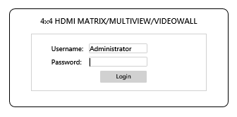
- USERNAME : admin
- PASSWORD : 123

MAIN PAGE:
- ROUTING：Include MULTIVIEW, MATRIX, VIDEOWALL three mode
- SETUP：OUTPUT RESOLUTION, HDCP SETTING, ID SETTING, PICTURE SETTING, OSD SETTING
- NETWORK：IP ADDRESS, SUBNET MASK GATEWAY, DHCP CLIENT, MEDIA TYPE, MAC FILTER
- SYSTEM：change password
- ADVANCE：Adjust user define layout of MULTIVIEW mode

Multiview
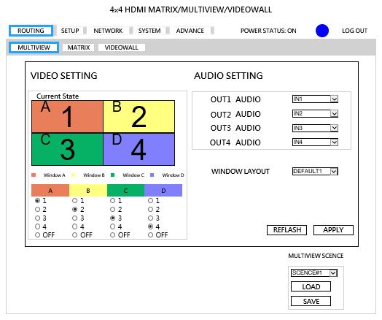
- VIDEO SETTING：Select video source of window A~D to input 1~4 or off
- AUDIO SETTING：Select audio source of output 1~4 from input 1~4 or off
- WINDOW LAYOUT：Select windows layout from default 1~4 or user define 1~4
- MULTIVIEW SCENCE：Select SCENCE 1~8 to load or save
- REFRESH：Refresh the information of host
- APPLY：Apply changes

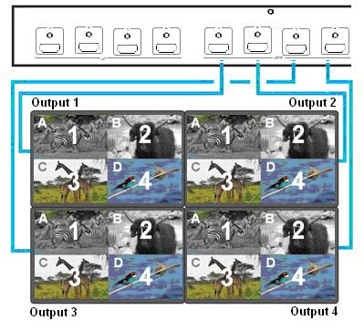
Matrix
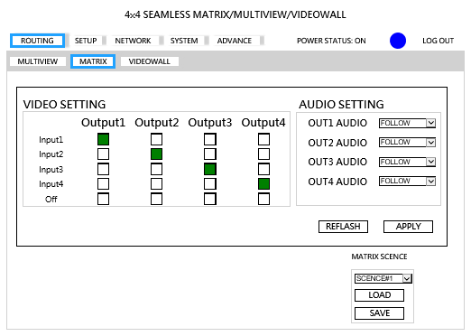
- VIDEO SETTING：Select video source of output 1~4 to input 1~4, off or follow.
- AUDIO SETTING：Select audio source of output 1~4 from input 1~4,off or follow
- MATRIX SCENCE：Select SCENCE 1~8 to load or save
- REFRESH：Refresh the information of host
- APPLY：Apply changes

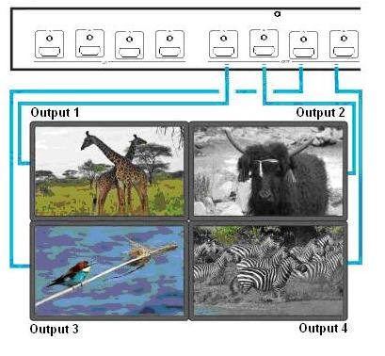

VIDEOWALL
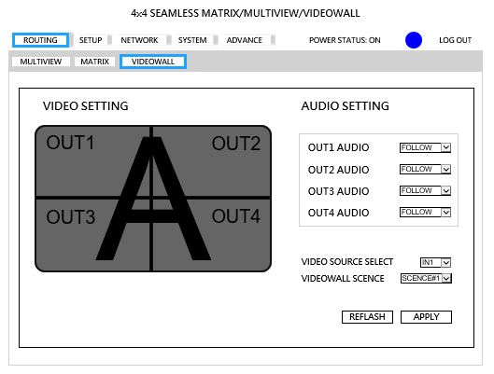
- VIDEO SETTING：Display videowall block of output 1~4
- AUDIO SETTING：Select audio source of output 1~4 from input 1~4,off or follow
- Video SCENCE：Select SCENCE 1~4 to load
- REFRESH：Refresh the information of host
- APPLY：Apply changes
*SCENCE 1 is factory default

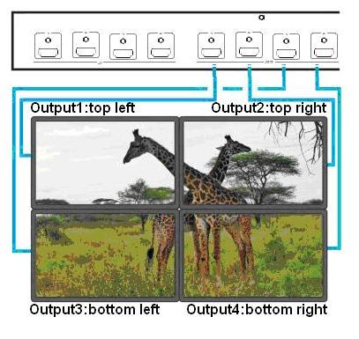

SETUP
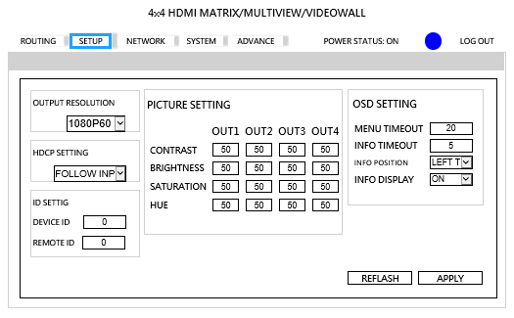
- OUTPUT RESOLUTION：Support 480P, 576P, 720P50, 720P60, 1080P24, 1080P50, 1080P60,Default 1080P60, 1024x768, 1280x800, 1280x1024, 1366x768, 1440x900, 1600x1200, 1680x1050, 1920x1200
- HDCP SETTING：Set HDCP always on or follow input.
- ID SETTING：Set DEVICE ID, Default 0, REMOTE ID, Default 0
- PICTURE SETTING：Set CONTRAST, BRIGHTNESS, SATURATION, HUE of output 1~4, Default 50
- OSD SETTING：Set MENU TIMEOUT, Default 20s, INFO TIMEOUT, Default 5s, INFO POSITION, Default LEFT TOP, INFO DISPLAY, Default ON
- REFRESH：Refresh the information of host
- APPLY：Apply changes

NETWORK
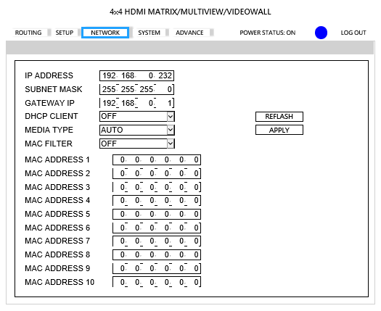
- IP ADDRESS：Set IP address, Default 192.168.0.200
- SUBNET MASK：Set Subnet mask, Default 255.255.255.0
- GATEWAY：Set gateway address, Default 192.168.0.1
- DHCP CLIENT：
ON:Get IP Address, Subnet Mask, Gateway from existing DHCP server
OFF:Set IP Address, Subnet Mask, Gateway by WebGUI or OSD menu manually, Default OFF
- MEDIA TYPE：Set link speed of Ethernet port to 10 / 100 / Auto detect, Default AUTO
- MAC FILTER: Add up to 10 registered MAC Address, only the MAC address which is in the list can be able to connect host by Ethernet, Default OFF.
- REFRESH：Refresh the information of host
- APPLY：Apply changes

SYSTEM
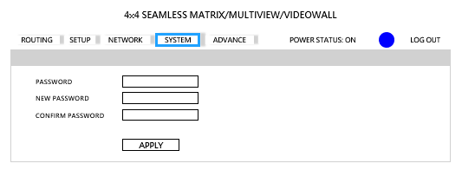
- PASSWORD：Enter old password, Default 123
- NEW PASSWORD：Enter new password
- CONFIRM PASSWORD：Enter new password again to confirm
- APPLY：Apply changes

ADVANCE
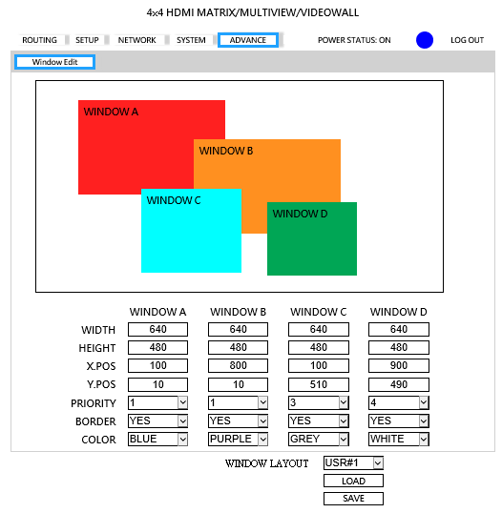
- WIDTH, HEIGHT: Set size of the windows.
- X.POS,Y.POS: Set top left position of window by x, y coordinate.
- PRIORITY: Set the priority of windows, 1 is top and 4 is bottom.
- BORDER: Select YES to show border of window, select NO to disable.
- COLOR: Set color of border.
- WINDOW LAYOUT：Select windows layout from user define 1~4 to load or save
- LOAD: Select windows layout from user define 1~4 to modify
- SAVE: Save windows layout to user define 1~4 after change the value
RS232 remote control command:
Connect the RS232 CONSOLE port to the COM port of the host by an F/M RS232 straight cable (pin 2 to pin 2; pin 3 to pin 3, pin 5 to pin 5)
Communication format is 9600, 8, N, 1 (9600 bps, 8 data bits, no parity check, 1 stop bit)

Operation Instruction format:
Command + △(Space) + Parameter + Enter
[Command] [Description]
----------------------------------- -------------------------------------------
POWER y Power on/standby
SMOUT1 n Output 1 from input n in seamless matrix
SMOUT2 n Output 2 from input n in seamless matrix
SMOUT3 n Output 3 from input n in seamless matrix
SMOUT4 n Output 4 from input n in seamless matrix
SMOUTALL n All output from input n in seamless matrix
SMADOOUT1 n Output 1 audio source from input n in seamless matrix
SMADOOUT2 n Output 2 audio source from input n in seamless matrix
SMADOOUT3 n Output 3 audio source from input n in seamless matrix
SMADOOUT4 n Output 4 audio source from input n in seamless matrix
SMADOOUTAll n All output audio source from input n in seamless matrix
MVWINA n Window A from input n in multiview
MVWINB n Window B from input n in multiview
MVWINC n Window C from input n in multiview
MVWIND n Window D from input n in multiview
MVWINALL n Set all windows from input n in multiview
MVADOOUT1 n Output 1 audio source from input n in multiview
MVADOOUT2 n Output 2 audio source from input n in multiview
MVADOOUT3 n Output 3 audio source from input n in multiview
MVADOOUT4 n Output 4 audio source from input n in multiview
MVADOOUTALL n All output audio source from input n in multiview
VDWALLRX n Input port n in video wall
VDWALLADOOUT1 n Output 1 audio source from input n in video wall
VDWALLADOOUT2 n Output 2 audio source from input n in video wall
VDWALLADOOUT3 n Output 3 audio source from input n in video wall
VDWALLADOOUT4 n Output 4 audio source from input n in video wall
VDWALLADOOUTALL n All output audio source from input n in video wall
DHCP y DHCP Client on/off
IP_ADDRESS [x.x.x.x] Set IP address
SUBNET_MASK [x.x.x.x] Set subnet mask
GATEWAY [x.x.x.x] Set gateway
MEDIA_TYPE z Set Ethernet link speed
MAC FILTER y MAC filter on/off
VERSION Display firmware version
HELP Show all commands
[SYMBOL] [PARAMETER]
--------------------------------------------------------------------------
N 0 | 1 | 2 | 3 | 4
n=0(OFF) n=1(INPUT1) n=2(INPUT2) n=3(INPUT3) n=4(INPUT4)
y 00=OFF, 01=ON
z 00=10M, 01=100M 02=AUTO
[x.x.x.x] Ethernet parameter
EX.192.168.0.1
Example:
SMADOOUT1△03 Set output 1 switch to input 3 in MATRIX mode
MVADOOUT3△04 Set output 3 switch to input 4 in MULTIVIEW mode
VDWALLADOOUT3△02 Set audio output from input 2 in VIDEOWALL mode

Commands are case insensitive.
The host will reply OK once string is correct, NG in case of incorrect string

Specification:
ITEM NO. | HM44
Resolution | 480i/p, 576i/p, 720p, 1080i/p@60Hz
HDMI Input | HDMI Type A x 4
HDMI Output | HDMI Type A x 4
Ethernet Connector | RJ45 x 1
RS232 Connector | DB9 Male x 1 (Console)
IR Carrier | ± 45 degree
Power Supply | DC 12V 4.16A
Power Consumption | 2A (Max)
Temperature | Operation: 0 to 55℃, Storage: -20 to 85℃, Humidity: up to 95%
Dimensions mm | 483 x 177 x 44
Weight g | 2300
Rev. A V1.50 170718

