§
User Manual

WP9EU-IP
Wallplate Control Panel
8 programmable buttons plus 1 audio mute button, 3 built-in programmable RS232, 2 RS485 and 2 IR connectors.
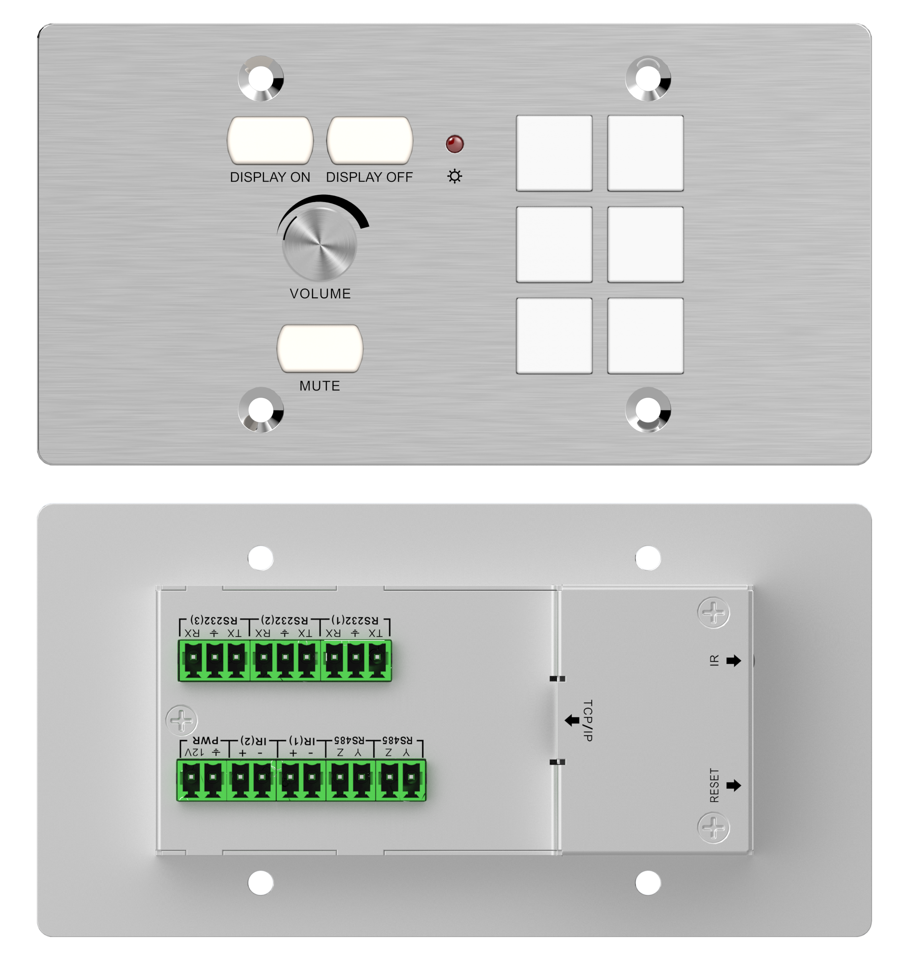

All Rights Reserved
Version: WP9EU-IP_2018V1.0
Preface
Read this user manual carefully before using the product. Pictures are shown in this manual for reference only, different models and specifications are subject to real product.
This manual is only for operation instruction, please contact the local distributor for maintenance assistance. The functions described in this version were updated till January, 2018. In the constant effort to improve the product, we reserve the right to make functions or parameters changes without notice or obligation. Please refer to the dealers for the latest details.

FCC Statement
This equipment generates, uses and can radiate radio frequency energy and, if not installed and used in accordance with the instructions, may cause harmful interference to radio communications. It has been tested and found to comply with the limits for a Class B digital device, pursuant to part 15 of the FCC Rules. These limits are designed to provide reasonable protection against harmful interference in a commercial installation.
Operation of this equipment in a residential area is likely to cause interference, in which case the user at their own expense will be required to take whatever measures may be necessary to correct the interference.
Any changes or modifications not expressly approved by the manufacture would void the user’s authority to operate the equipment.

SAFETY PRECAUTIONS
To ensure the best performance from the product, please read all instructions carefully before using the device. Save this manual for further reference.
- Unpack the equipment carefully and save the original box and packing material for possible future shipment
- Follow basic safety precautions to reduce the risk of fire, electrical shock and injury to persons.
- Do not dismantle the housing or modify the module. It may result in electrical shock or burn.
- Using supplies or parts not meeting the products’ specifications may cause damage, deterioration or malfunction.
- Refer all servicing to qualified service personnel.
- To prevent fire or shock hazard, do not expose the unit to rain, moisture or install this product near water.
- Do not put any heavy items on the extension cable in case of extrusion.
- Do not remove the housing of the device as opening or removing housing may expose you to dangerous voltage or other hazards.
- Install the device in a place with fine ventilation to avoid damage caused by overheat.
- Keep the module away from liquids.
- Spillage into the housing may result in fire, electrical shock, or equipment damage. If an object or liquid falls or spills on to the housing, unplug the module immediately.
- Do not twist or pull by force ends of the optical cable. It can cause malfunction.
- Do not use liquid or aerosol cleaners to clean this unit. Always unplug the power to the device before cleaning.
- Unplug the power cord when left unused for a long period of time.
- Information on disposal for scrapped devices: do not burn or mix with general household waste, please treat them as normal electrical wastes.

Contents
1. Introduction 1
1.1 Introduction to WP9EU-IP 1
1.2 Features 1
1.3 Package List 1
2. Panel Description 2
2.1 Front Panel 2
2.2 Rear Panel 3
3. System Connection 4
4. Control Software 5
4.1 Basic Setting 5
4.2 Panel Set 8
4.3 Action List 9
4.4 Event setting 10
4.4.1 RS232 Setting 10
4.4.2 IR Setting 12
4.4.3 TCP/IP Setting 15
4.4.4 Delay Setting 16
4.4.5 Compare Setting 17
4.4.6 LED Setting 18
4.4.7 Toggle Setting 19
4.5 Event List 21
5. Specification 22
6. Panel Drawing 23
7. Troubleshooting & Maintenance 24
8. Customer Service 25

Introduction

Introduction to WP9EU-IP
The WP9EU-IP is a wallplate control panel with 8 programmable buttons plus 1 audio mute button. It features 3 built-in programmable RS232, 2 RS485 and 2 IR connectors.
The programmable control panel can fully control the compatible device via TCP/IP, RS232, RS485 and IR, such as matrix switcher, scaler switcher, projectors, screens, etc. Use the device for presentations in showrooms, classrooms, and boardrooms.

Features
- Features 8 programmable buttons plus 1 audio mute button, 3 built-in programmable RS232, 2 RS485 and 2 IR connectors.
- Each button can be programmed to send RS232, RS485, IR or TCP/IP commands simultaneously to control third party devices.
- The unit can be easy configured using the supporting control panel via the ENTERNET port.
- The volume control buttons is specially designed for various applications.
- Crystal and backlit buttons with easy user-friendly customizable changeable labels.
- The backlit brightness is controllable.

Package List
- 1 x WP9EU-IP | - 1 x Power adapter (12VDC 1A)
- 5 x 2-pin pluggable terminal blocks | - 3 x 3-pin pluggable terminal blocks
- 6 x Button caps | - 1 x Button label
- 1 x User manual

Note: Please confirm if the product and the accessories are all included, if not, please contact with the dealers.

Panel Description

Front Panel

No. | Name | Description
1 | Button | 6 crystal and luminescent buttons, programmable functions can be customized via the Control Software.  Each label within a button can be easily changed. Simply select the label you need and change it as shown below:  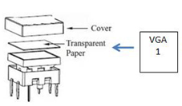
2 | Power LED | The LED illuminates red when power is applied.
3 | DISPLAY ON | The button can be customized to turn on the third-party device.
3 | DISPLAY OFF | The button can be customized to turn off the third-party device.
4 | VOLUME | The rotary knob can be customized as Volume Up and Volume Down buttons for specific application.
5 | MUTE | The button can be customized as Toggle Mute and Unmute buttons for specific application.

Rear Panel

No. | Name | Description
1 | ETHERNET | RJ45 connector for connecting PC to run the Control Software to customize the programmable functions for all buttons.  After buttons programming, the RJ45 connector should be connected to the third-party device which needs to be controlled via TCP/IP.  Note: The wallplate control panel and third-party devices can connected to the LAN to facilitate remote control and simplify system connection.
2 | RS232 (1) ~ RS232 (3) | 3-pin RS232 terminal blocks for connecting the third-party devices which need to be controlled via RS232.
3 | RS485 (4) ~ RS485 (5) | 2-pin RS485 terminal blocks for connecting the third-party devices which need to be controlled via RS485.
4 | IR (1) ~ IR (2) | 2-pin IR terminal blocks for connecting with IR emitters to control the third-party devices via IR.
5 | PWR(12V) | 2-pin terminal block for connecting 12V DC power adaptor.
6 | IR Sensor | Built-in IR receiver for receiving IR code from IR remote to build the IR database.
7 | RESET | Press and hold this button for 3 seconds until the power LED goes out. Then the LED will light up while the device is restored to factory defaults successfully.

System Connection
The WP9EU-IP can active different ports at the same time. It means that every button can send RS232, RS485, TCP/IP and IR control signal synchronously.

The demo system diagram as below:

- Connect the WP9EU-IP to a LAN port of Wireless Route.
- Connect a control PC to the Wireless Route.
- Connect the third-party devices (such as matrix switcher and scaler switcher) to the LAN port of Wireless Route.
- Connect the third-party devices (such as matrix switcher, scaler switcher and projector) to RS232 (1), RS232 (2) and RS232 (3) ports.
- The third-party devices which support RS485 communication can be connected to RS485 (4) and RS485 (5) ports.
- Connect the IR Emitters to IR (1) and IR (2) ports.
- Plug in 12V DC power supply adapter.

Note: The control PC can be directly connected to the TCP/IP port of WP9EU-IP to customized button functions. After buttons programming, disconnect the PC, and then connect the third-party device to the TCP/IP port.

Control Software

Basic Setting
The Control Software is used to easily set functions for every button.
- According to the system diagram to establish system connection.
- The default IP of WP9EU-IP is 192.168.0.178 (modifiable), the network segment of control PC must be set the same as the WP9EU-IP’s.

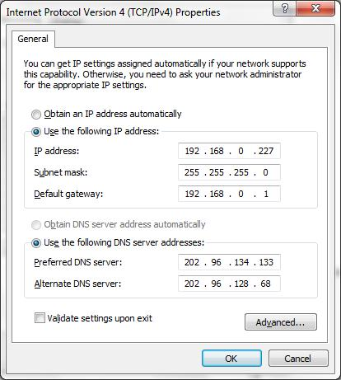
Same network segment as the switcher

- Installation/uninstallation of Control Software:
- Installation: Copy the software package to the control PC.
- Uninstallation: Delete all the software files in corresponding file path.
- Double-click the below icon to run this software:
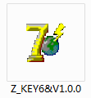
The below main window has five parts: Panel Set, TCP/IP, Action List, Event Set and Event List.
Set events for the selected button action.
Show all events for the selected key action.
Show all button actions, and any action can be chosen for setting events.
Show IP addresses of all connected wallplate control panels in LAN.
Panel Set: Click any button to set its action.
Set events for the selected key action.
Show all events for the selected key action.
Show all key actions, and any action can be chosen for setting events.
Show IP addresses of all connected wallplate control panels in LAN.
Panel Set: Click any key to set its action.

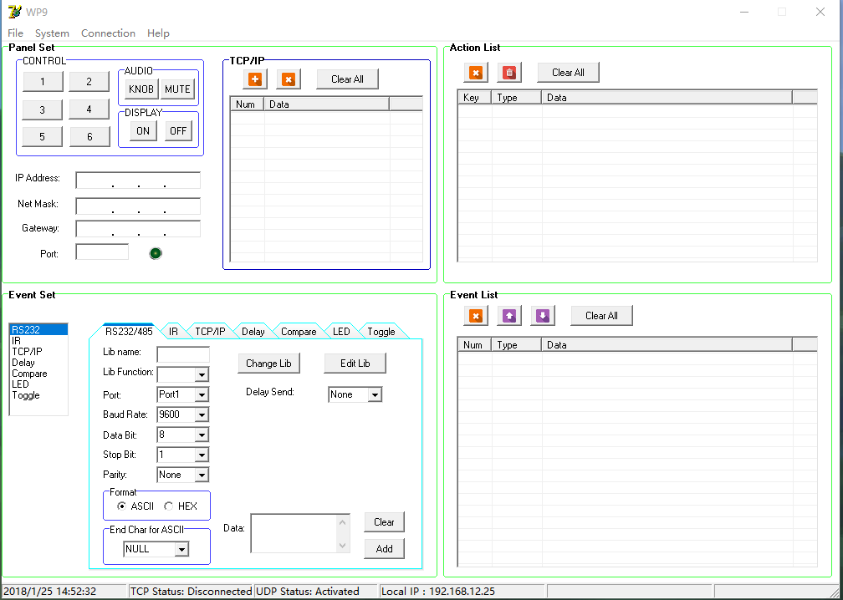

Menu Options of Control Software:
The header of the main window features four titles including File, System, Connection and Help.

- Click “File” → “Open” to invoke an available configuration file.
- Click “File” → “Save” to save the current configuration data into the installation directory.
- Click “File” → “Save as” to export all configuration information and save as a file.

- Click “System” → “Version” to query the current software version.
- Click “System” → “Message” to query the Link Status, Machine Type, Software Version, IP Information, MAC address.
- Click “System”→ “Software Update” → Open upgrade Web page (http://192.168.0.178:4001/) on IE → Type User ID (admin) and Password (123456) → upload update file → Click “Upload” → Click “Reset MCU”.
- Click “System” → “Factory Defaults” to restore factory defaults.

- Click “Connection” → “TCP/IP” → “Reconnect” to refresh all connected WP9EU-IP.
- Click “Connection” → “Read from Device” → to load the MCU data of the selected WP9EU-IP to control software.
- Click “Connection” → “Write to Device” → to download the current configuration data of control software to the selected WP9EU-IP.

Button Setting Procedure:
The nine programmable buttons should be set by the following steps:
- Click any button to set key actions, refer to 4.2 Panel Set.
- Select any key action, refer to 4.3 Action List.
- Set the button functions for the selected key action, refer to 4.4 Event Setting and 4.5 Event List.

Panel Set
The below Panel Set part shows 9 customizable buttons can be programmed via the control software.
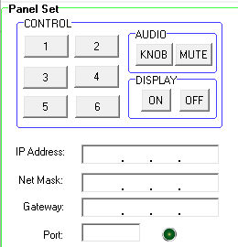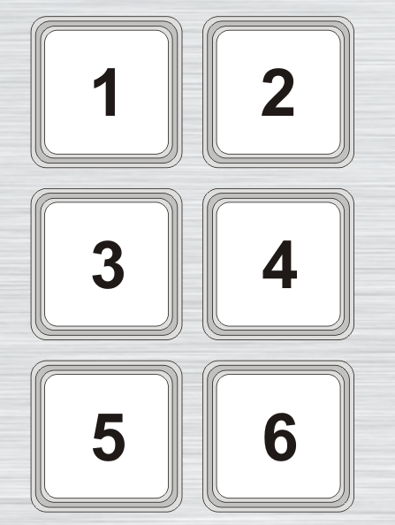

Buttons 1-6, KNOB, MUTE, ON, OFF, correspond to the buttons on WP9EU-IP. For example, click the button 1 to set its key action as below:
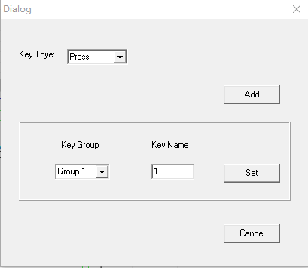
Key Type:
Press: Execute events when press button.
Release: Execute events when release button.
Toggle: The button can be regard as composite key, press and press again to execute different events.
Built key group for LED setting.

Action List
All key actions will be shown on the below action list.

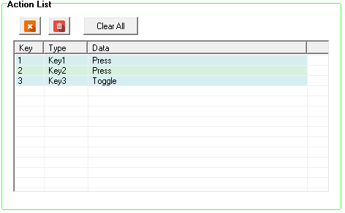
Delete the selected action.
Delete all invalid actions which have no events.
Empty all actions.

Event setting
The Event Set part supports RS232, RS485, IR, TCP/IP, Delay, Compare, LED and Toggle setting. Before set events, at least one key action must be added first. The following introduction is about how to set events for each action.

RS232 Setting
This item is used for setting the events of the selected key action to control the third-party device through RS232 (1~3) and RS485 (4~5) ports.

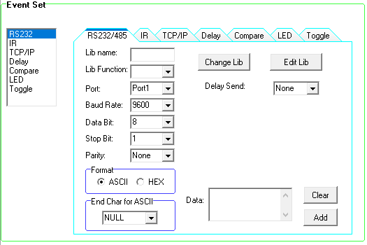

Operation procedure:
- Select a key action in action list.
- Set the “Lib Name” and “Lib Function” as needed.
- Select the RS232/485 port.
- Confirm and set the baud rate, data bit, stop bit and parity.
- Type RS232 command in data box, and then press “add” to save.
- The RS232 data also can be selected from library. Click “Change Lib” to select an available library file, or click “Edit Lib” to create a new library file as below:
Open/create a library
Type RS232 command for device control.
Create/delete the function name of the command.
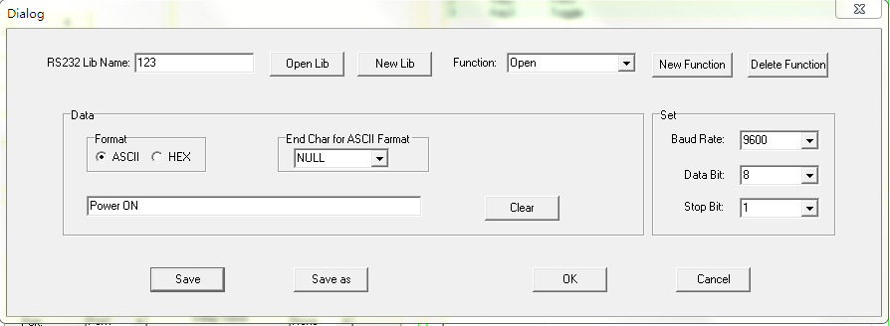

Note: Once set up, please press “Save” to save the setting or press “Save as” to save the setting as a file, and then press “OK”.

- The number of transmission strings and the delay time between strings can be set.
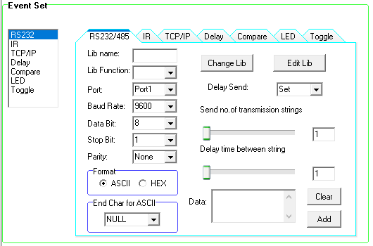

IR Setting
This item is used for setting the events of the selected key action to control the third-party device through IR (1~2) ports.

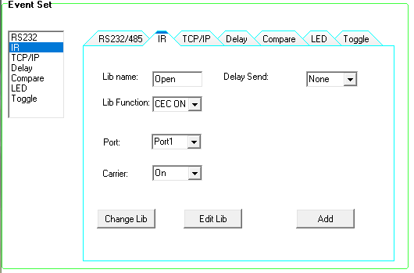

Operation procedure:

- Select the key action in action list.
- Set the “Lib name” and “Lib Function” as needed.
- Select the IR port.
- Set the IR carrier mode: On/Off.
- Click “Change Lib” to select an available library file or click “Edit Lib” to create or edit a library file as below:
IR leaning procedure:
Click “Learn” to enter IR learning mode.
Put the IR Remote close to the IR sensor of wallplate control panel.
Press any button on the IR Remote to send the IR code to the IR sensor, and the IR edit box will refresh the IR data.
Follow the above steps can learn other function of the remote buttons.
Note: The IR learning mode will be exit automatically while if no operation within 3 seconds.
Create/delete/rename the function name of the IR data
Open/create a library
Show IR data.

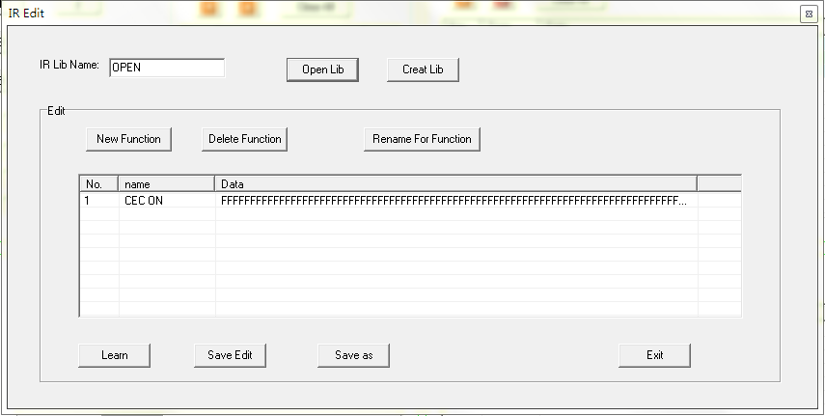

Note: Once set up, please press “Save Edit” to save the setting or “Save as” to save as a file, and then press “OK”.
- The number of transmission strings and the delay time between strings can be set.

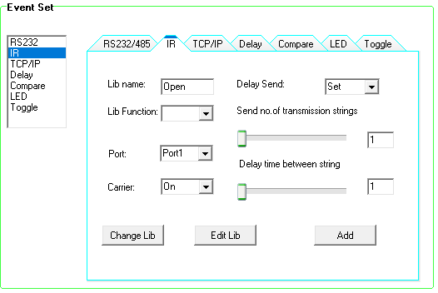

TCP/IP Setting
This item is used for setting the events of the selected key action to control the third-party device through TCP/IP port.
Type the IP address of third-party device.
Type the control command.
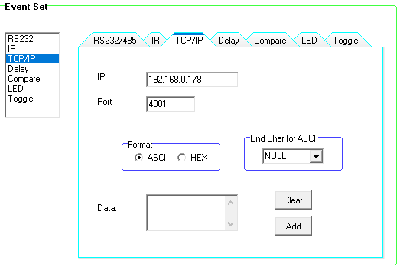

Delay Setting
This item is used for setting the delay time between two events. If set the delay time to be 3 seconds, it means that the first event starts executing at 12:00:00, followed by the second event executing at 12:00:00:03.

The delay time setting showed as below:
Hour: 0~23
Minute: 0~59
Second: 0~59

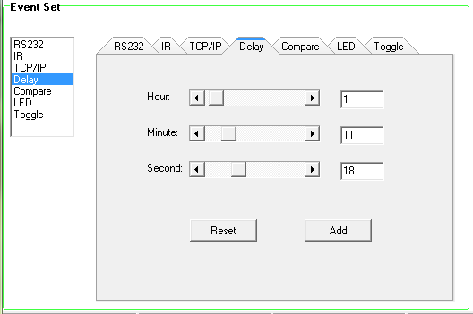

Compare Setting
This item is used for comparing the RS232 feedback commands. When trigger button to send RS232 command to the third-party device, the device will send back a feedback command. If we add the correct command in the data box, the WP9EU-IP will compare it with the received feedback command to verify the availability of sending command. The compare setting showed as below:
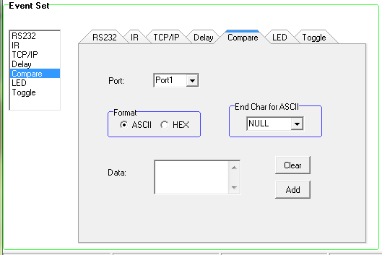
Enter the correct commands, please don’t miss any character.

Operation procedure:
- Select the key action in action list.
- Select the RS232 port.
- Set the command format ASCII or Hex, and then set the terminator for ASCII.
- Type the correct RS232 command in data box, and then press “add” to save the command.
- Add an event that the LED lights up to indicate the comparison result.
- The executing priority of events in event list is from top to bottom, so that the comparing function can be used for the key action which with three or more events.

LED Setting
This item is used for setting the LEDs status of programmable buttons to indicate the results of executing event.

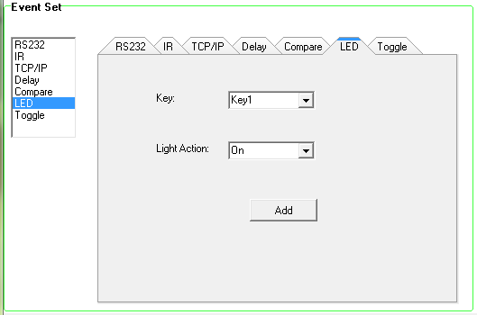
On: Switch on the LED of the selected Key1.
Off: Switch off the LED of the selected Key1.
On/Other off: Switch on the LED of the selected Key1 and switch off the others.
On/Group off: Switch on the LED of the selected Key1 and switch off the others in the same group.

Toggle Setting
The key action type can be set as “Toggle” that enable the button to be a composite key.

Here take Key1 as an example to introduce the “Toggle Setting”.

Operation procedure:
- Click “1” and set its key type as “Toggle”.
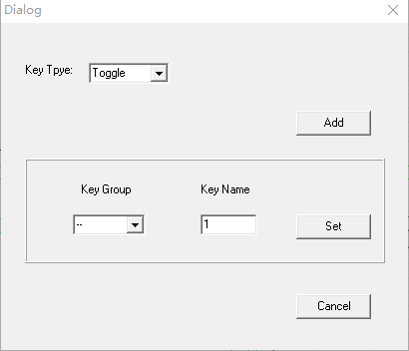
- Add toggle & RS232 events for the key action.
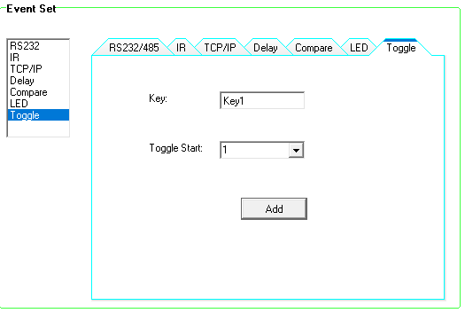
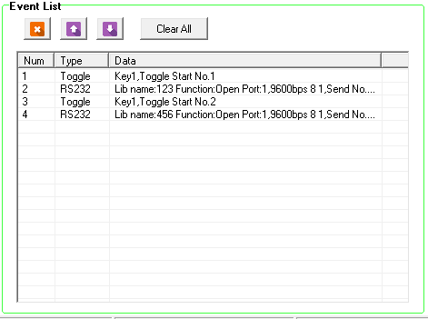
- Press the button 1 to execute the second event, and then press again to execute the fourth event.

Event List
The event list shows all events of the selected key action. The executing priority of events is from top to bottom, see the picture below. If there is an event execute incorrectly, all subsequent events will not be executed.

Delete the selected event.
Adjust the execution order for events.
Empty all events.

Specification
Control Port | (1) TCP/IP, (3) RS232, (2) RS485 and (2) IR out
Control Port Connector | (1) RJ45  (3) 3-pin pluggable terminal blocks  (4) 2 pin pluggable terminal blocks
Control Buttons | (6) Programmable buttons  (2) Programmable display control buttons  (1) Programmable volume knob  (1) Programmable MUTE button
Other | (1) Built-in IR sensor
Baud Rate | Supports 2400, 4800, 9600, 19200, 38400, 56000, 57600, 115200.
Software | WP9EU-IP
Power Consumption | 1W (Max)
Operation Temperature | -10 ~ +55℃
Storage Temperature | -25~ +70℃
Relative Humidity | 10% ~ 90%
Power Supply | Input: 100VAC~240VAC, 50/60 Hz;  Output: 12VDC 1A
Net Weight | About 300g
Dimension（W*H*D） | 151mm x 80mm x 38mm

Panel Drawing

Troubleshooting & Maintenance

- When WP9EU-IP cannot work, please check and make sure the power cord connection is well, power connector cannot be mixed or connect wrong. Then restart, if still not work, the WP9EU-IP may be broken. Please send it to the dealer for repairing.

- When connect unsuccessfully, please make sure the network segment of control PC and the WP9EU-IP is same.

- When the LED of a button cannot be lighted, please check if there is a compare event in this button. If yes, delete the compare and try again. If still not work, the LED may be broken. Please send the unit to dealer for repairing.

- When serial commands sending without function executed, please check the baud rate and make sure is correct, and the serial connection is well.

- If the controlling queue is confused when use loop function, please reboot the WP9EU-IP.

If your problem still remaining after following the above troubleshooting steps, please contact your local dealer or distributor for further assistance.

Customer Service
The return of a product to our Customer Service implies the full agreement of the terms and conditions hereinafter. There terms and conditions may be changed without prior notice.

- Warranty
The limited warranty period of the product is fixed three years.

- Scope
These terms and conditions of Customer Service apply to the customer service provided for the products or any other items sold by authorized distributor only.

- Warranty Exclusions:
- Warranty expiration.
- Factory applied serial number has been altered or removed from the product.
- Damage, deterioration or malfunction caused by:
- Normal wear and tear.
- Use of supplies or parts not meeting our specifications.
- No certificate or invoice as the proof of warranty.
- The product model showed on the warranty card does not match with the model of the product for repairing or had been altered.
- Damage caused by force majeure.
- Servicing not authorized by distributor.
- Any other causes which does not relate to a product defect.
- Shipping fees, installation or labor charges for installation or setup of the product.

- Documentation:
Customer Service will accept defective product(s) in the scope of warranty coverage at the sole condition that the defeat has been clearly defined, and upon reception of the documents or copy of invoice, indicating the date of purchase, the type of product, the serial number, and the name of distributor.

Remarks: For further assistance or solutions, please contact your local distributor.

