HDMI 4 input 1 output Quad/Multi-viewer & Seamless Switcher
ITEM NO.: HM41E 4 x 1 HDMI Multiviewer & Seamless Switcher
The HDMI Quad Multi-viewer allows you to display HDMI video signals from 4 different sources onto one HDTV. Its support Quad/POP/full screen with 6 modes, the special feature built in auto switching function between 4 different sources. It is easy operation with great feature for viewing or monitoring multiple videos on one screen at the same time from video devices such as computer, Blu-ray player, cable box, DVR, surveillance camera, etc. Perfect to use at surveillance, advertising, education, industry and commercial applications, private Home Theatres etc.
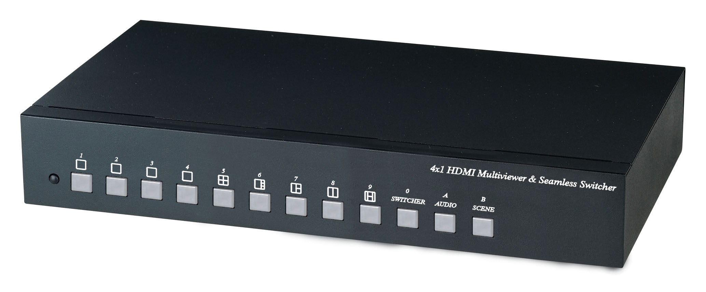
HM41E 4 x 1 HDMI Multiviewer & Seamless Switcher
Features:
- Multiplexes 4 HDMI input into 1 HDMI output.
- Support resolution up to 1080p 60Hz.
- Support scaler up to 1080p functions and digital audio format LPCM 2.0.
- Control option: IR remote control, front panel button, RS232.
- Support Quad, multi-view and seamless switch.
- Support auto switching between 4 sources.
- HDM 1.3a, HDCP 1.2 ,DVI 1.0 complaint.
- Support different mode display: Quad, picture on picture (POP) and full screen display.
- Perfect for control remote machines and security monitoring systems, digital signage application.

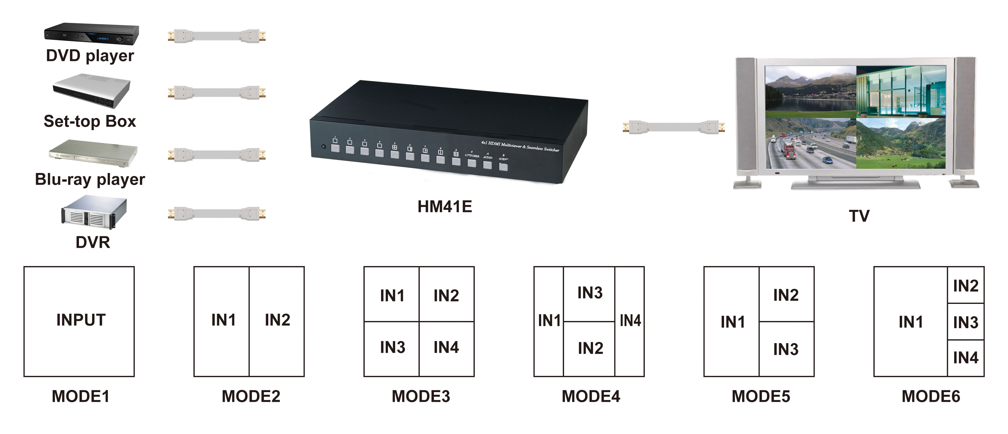
Panel View:
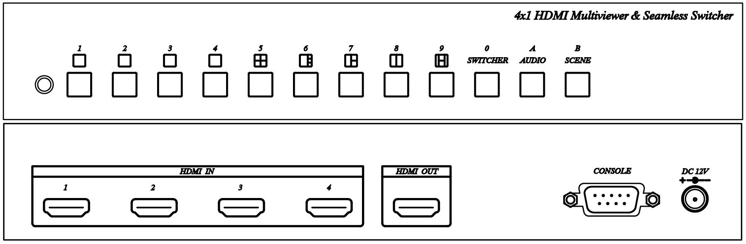
Panel Button Function:
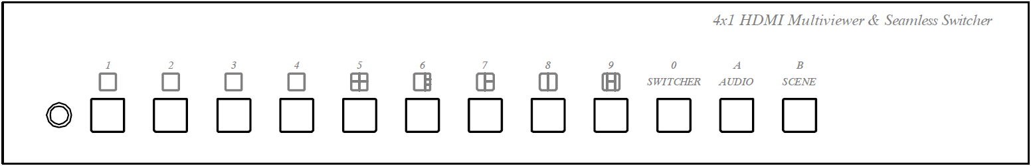
Button | Function
 | Select Video 1
 | Select Video 2
 | Select Video 3
 | Select Video 4
 | Quad Picture Display
 | Quad Picture Display (one big window with three small window), press this button again to change 4 video sequence.
 | Select 3 Video Display (Only select input video 1,2,3)
 | Select 2 Video Display, press this button again to select video input 1,2 or 3,4.
 | Select 4 Video Display
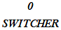 | Auto Switching
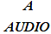 | Audio Selection
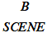 | Scene Selection

Seamless Switch Function：
Press button 1 – 4: the video output is a single full screen, and the button light on indicates the source of video input.
Multi-view Switch Function：
Press button 5 – 9: the video output is multi-view window, and the button light on indicates the Multiview mode.
SWITCHER Function：
SWITCHER as video auto switching function, you could select two or four videos for automatically display, the switching time duration setting as below:
Press SWITCHER button: the button light on, then press button 1 – 4 to select the video
for auto switching.
Press button 5 – 9 to select the auto switching timing :
5 : 5 seconds
6 : 10 seconds
7 : 20 seconds
8 : 30seoncds
9 : 60seconds
To press the SWITCHER button again to leave switching mode.
AUDIO Function：
Multiview mode display only could select one auido input, the setting as below:
Press AUDIO button, the button light on, then then press button 1 – 4 to select the audio soure. To press AUDIO button again to leave audio slection mode.
SCENE Function：
SCENE button for the scene function, there are 9 sets of saved scene mode for easy save and load.
SCENE Saved method:
Press SCENE button 3 seconds until button light flash, then press button 1- 9 to save. Press SCENE button again to exit.
SCENE Load method:
Press SCENE button, the button light on, press button 1 - 9 for load and exit.
Demo Function：
Demo mode: 5 - 9 as multi-view window will be auto switching by sequence.
Setting as below:
Press the SCENE button, the button light, press the SWITCHER button to turn on the
DEMO mode. To press the SCENE button again to leave DEMO mode.
Output Resolution:
Press button 1 and power on, output resolution as 720p@60Hz.
Press button 2 and power on, output resolution as 1080p@60Hz.
IR Remote Control Function:
This device could use IR remote control for function setting and control, the ID number must be setup before using IR remote control or change new batteries. Setup IR remote ID number: Press and hold“Power”button and press number 0.
Button | Function
1 | same as panel button 1
2 | same as panel button 2
3 | same as panel button 3
4 | same as panel button 4
5 | same as panel button 5
6 | same as panel button 6
7 | same as panel button 7
8 | same as panel button 8
9 | same as panel button 9
0 | same as panel SWITCHER
A | same as panel AUDIO
B | same as panel SCENE
＊ | SCENE save setting: B → ＊ → 1 ~ 9

、▲、▼、◀、▶、＃、MENU、ENTER: Reserved
CONSOLE Function：
- Firmware updated.
- RS232 Serial Remote Control function as below:

Connect the RS232 CONSOLE port to the COM port of the host by an RS232 straight cable (pin 2 to pin 2; pin 3 to pin 3, pin 5 to pin 5)

Communication format is 115200, 8, N, 1 (115200 bps, 8 data bits, none parity check, 1 stop bit)
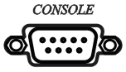
Command Mode Instruction:
[COMMAND] [DESCRIPTION]
--------------------------------------------------------------------------------------------------------------
MODE m Select Mode.

SWITCHER Enable/Disable Switcher Mode.

SWITCHER c Add/Delete "Video Source" for Switcher Mode

TIME t Switcher Time.

AUDIO Enable/Disable Audio Mode.

AUDIO a Select Audio.

IR i IR Remote ID setting

SAVE n Save Scene.

LOAD n Load Scene setting.

DEFAULT Reset to Default.

DEMO Demo Mode.

SIGNAL Display input signal status.

STATUS Display setting.

VERSION Display firmware version.

? Show all commands.

[SYMBOL] [PARAMETER]
--------------------------------------------------------------------------------------------------------------
a 1 | 2 | 3 | 4
c 1 | 2 | 3 | 4
n 1 | 2 | 3 | 4 | 5 | 6 | 7 | 8 | 9
m 1 | 2 | 3 | 4 | 5 | 6 | 61 | 62 | 63 | 64 | 7 | 8 | 9
i 1 | 2 | 3 | 4 | 5 | 6 | 7 | 8 | 9 | 0
t 5 | 6 | 7 | 8 | 9 (5s | 10s | 20s | 30s | 60s)
Space characters between the command and parameters can be ignored。

Reset Factory Default：
Press and hold SCENE button then power on, SCENE button LED flash will clear all the saved data and setup the output resolution at 1080p@60Hz.

Package Include:
HM41E x 1 piece
IR Remote Control x 1 piece
Power adapter x 1 piece
Rubber Pad x 4 pieces
Mounting screws x 1 bag
Specifications:
ITEM NO. | HM41E
Video Input Resolution | 480p、576i、720p@50/60Hz、1080i@50/60Hz、1080p@24/25/50/60Hz
Video Output Resolution | 720p@60Hz、1080p@60Hz
Video output/Input Interface | HDMI Type A x 1 / HDMI Type A x 4
IR Carrier | 38Khz / ±45° / 5M
CONSOLE | RS-232(F) x 1
Function Button | Button x 12
Power Supply | DC 12V / 1A
Power Consumption | 660mA
Temperature | Operation: -10 to 70℃, Storage: -20 TO 85℃,  Humidity: up to 95%
Dimension mm | 253 x 144 x 40
Weight g | 840
Rev. A

