4K HDMI Audio Extractor With Up/Down Scaler Series
ITEM NO.: HAE01 4K HDMI Audio Extractor With Up/Down Scaler 1 in 2 out
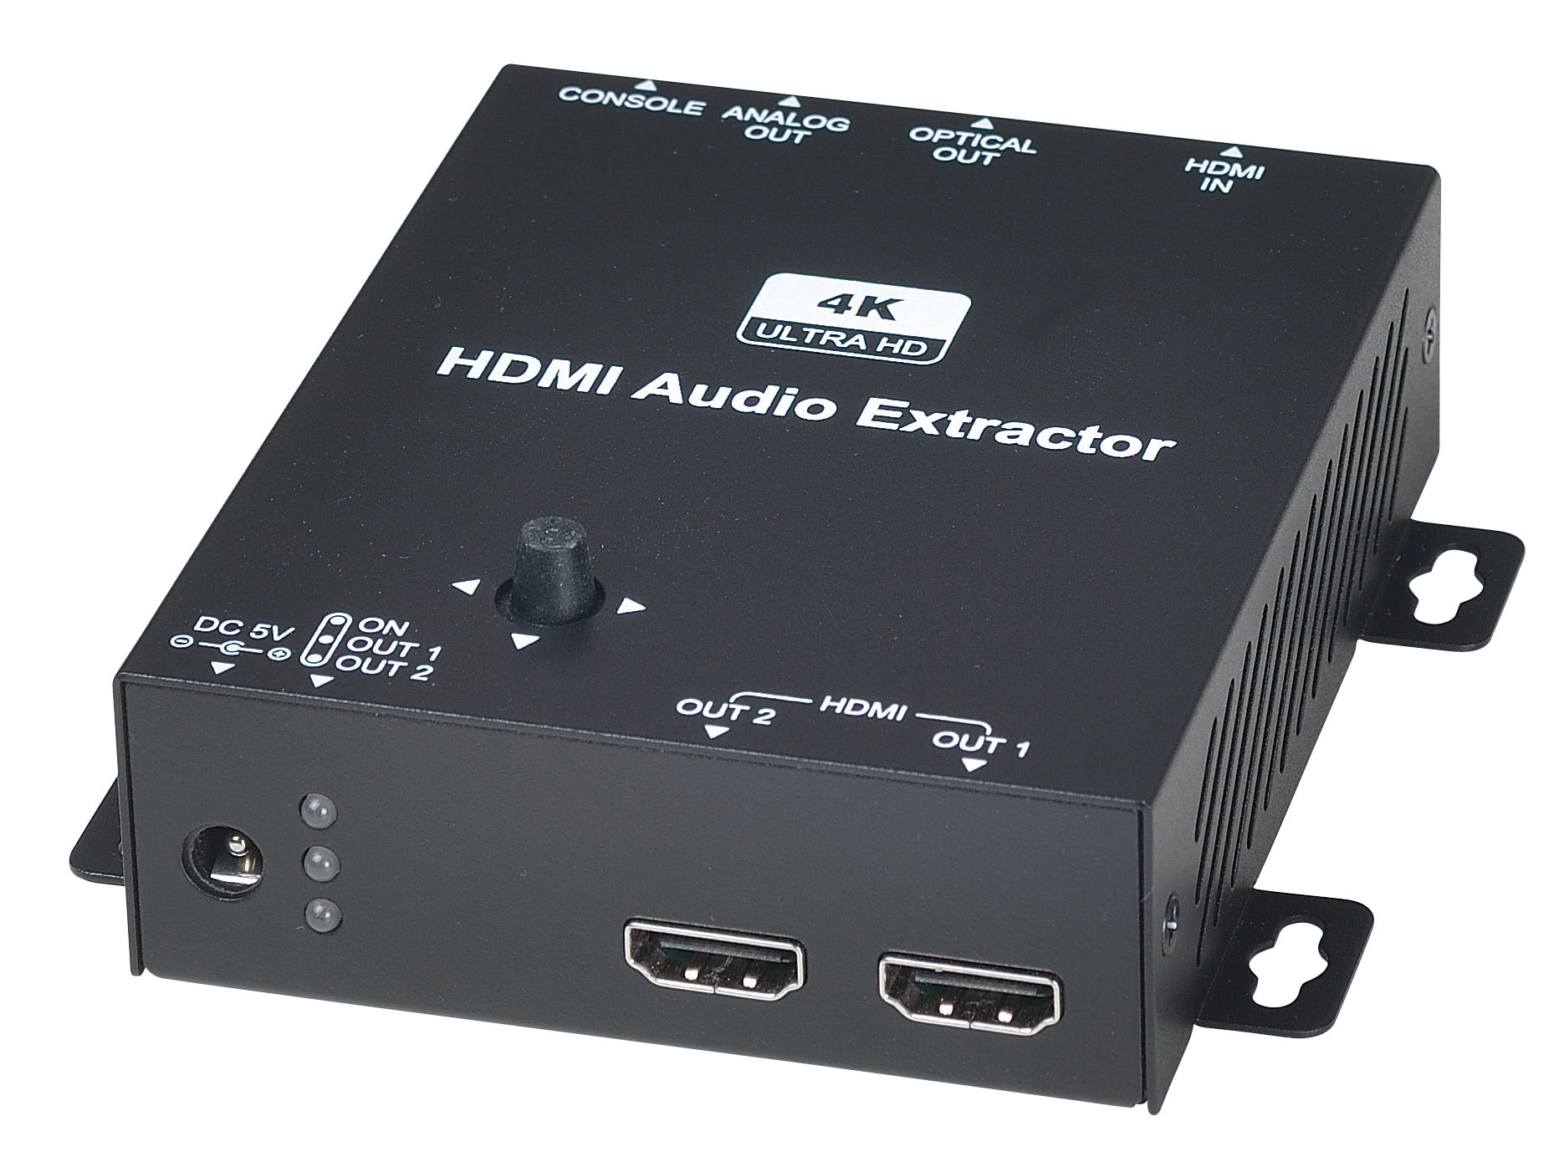
The HAE01 is an HDMI multifunction tool: allow you to extract 4K HDMI for both digital optical S/PDIF (Toslink) and stereo analaog audio signal for use by an amplifier or AV receiver. With a special feature to do upscale 1080p signal up to 4K or Downscale 4K signal to 1080p. Full OSD operation by using 5 way joystick switches for easy set up and doing EDID management. It is a perfect solution for integrating a 4K source into a 1080P HD system or vice versa.

HAE01 4K HDMI Audio Extractor with Up/Down Scaler 1 in 2 out
- Support HDMI 2.0, HDCP 2.2, 4K@60Hz 4:4:4 18Gbps（6Gbps per color）3D,HDR.
- Support extracts the 4K HDMI audio and output to a multi-channel digital or analog audio signal.
- Allows you to route HDMI audio simultaneously via S/PDIF and 3.5mm stereo audio outputs.
- HDMI audio output: LPCM7.1@192KHz, Dolby TrueHD, DTS-HD MA.
- Input: HDMI x 1, Output: HDMI x 2, Optical out x 1, analog stereo out x 1.
- Support uncompressed audio such as LPCM.
- Support 1080p to 4K upscale and 4K to 1080p downscale.
- Support 4K 4:4:4 convert to 4:2:0.
- Audio output support: up to 7.1 channel
- Support CEC pass-through
- Built in EDID management, 2/5.1/7.1 patched EDID.
- Built in 5 way joystick switch for full OSD operation.

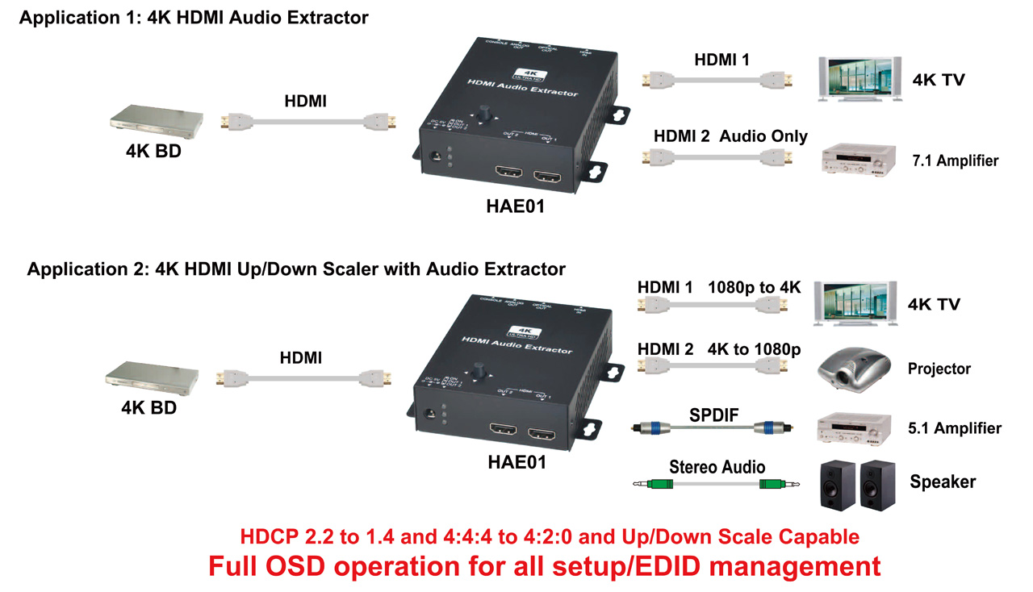

5 way Joystick Switch Function:


MENU Operation

SW1 | Function
 | Up
 | Down
 | Left
 | Right
 | confirm

MENU :
Main Menu | Sub Menu | Sub Menu Function
OUTPUT 1 MODE | NORMAL | Output video same as input Video
OUTPUT 1 MODE | UPSCALE | 1080P Upscale to 4K
OUTPUT 1 MODE | EXIT | Exit Sub Menu
OUTPUT 1 SUBSAMPLING | NORMAL | Output color subsampling same as Input
OUTPUT 1 SUBSAMPLING | 4:4:4 →4:2:0 | 4K 4:4:4 convert to 4K 4:2:0
OUTPUT 1 SUBSAMPLING | NORMAL | Output color subsampling same as Input
OUTPUT 1 AUDIO MODE | OUTPUT 1 AUDIO MODE | Audio Selection
OUTPUT 1 AUDIO MODE | NORMAL | audio output
OUTPUT 1 AUDIO MODE | MUTE | No audio output
OUTPUT 1 AUDIO MODE | EXIT | Exit Sub Menu
OUTPUT 2 MODE | AUDIO ONLY | Audio output only
OUTPUT 2 MODE | DOWNSCALE | 4K downscale to 1080P
OUTPUT 2 MODE | SPLITTER | Distribution Mode（Output signal same as OUTPUT 1）
OUTPUT 2 MODE | EXIT | Exit Sub Menu
EDID(VIDEO) | AUTO | Use OUTPUT 1 EDID as priority, if OUTPUT 1 and OUTPUT 2 not connected with TV, Default as 4K
EDID(VIDEO) | OUTPUT 1 | Use OUTPUT 1 EDID
EDID(VIDEO) | OUTPUT 2 | Use OUTPUT 2 EDID
EDID(VIDEO) | PRESET 4K | Default 4K 60Hz 8bit
EDID(VIDEO) | PRESET 1080P | Default 1080P 60Hz 8bit
EDID(VIDEO) | EXIT | Exit Sub Menu
EDID(AUDIO) | AUTO | Use OUTPUT 2 as priority, If OUTPUT 1 and OUTPUT 2 not connected with TV, Default as LPCM 2.0
EDID(AUDIO) | OUTPUT 1 | Use OUTPUT 1 EDID
EDID(AUDIO) | OUTPUT 2 | Use OUTPUT 2 EDID
EDID(AUDIO) | 5.1 AUDIO | Default LPCM 5.1
EDID(AUDIO) | 2.0 AUDIO | Default LPCM 2.0
EDID(AUDIO) | EXIT | Ext Sub Menu
EXIT & SAVE |  | Save setting and Exit MENU

Panel View:

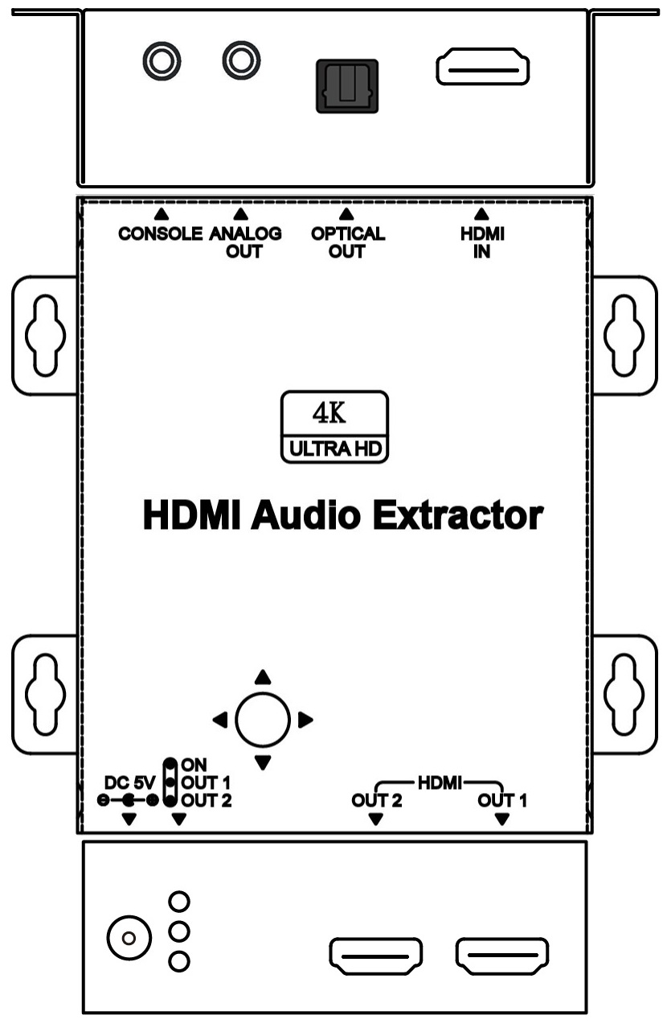

LED Indication:

Color | LED
GREEN | Power
BLUE | Output 1
RED | Output 2

RS232 Define:
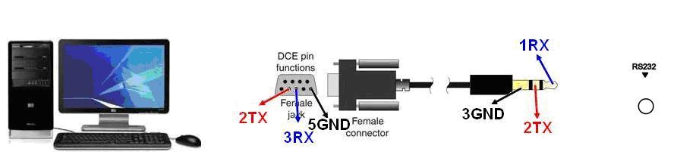
DB9(F)/3.5mm STEREO PHONE JACK

DB9(F)/3.5mm STEREO PHONE JACK
RS232 |  | 3.5 mm Phone Jack
Footprint | Define | Footprint | Define
Pin 2 | TX | Pin 1 | RX
Pin 3 | RX | Pin 2 | TX
Pin 5 | GND | Pin 3 | GND

Trouble Shooting:
- CEC function only works Output 1.
- Any HDMI output with HDCP2.2 compatible issues will cause HDMI no video output, Under HDCP 2.2 mode: any one monitor HDCP authorization failed will cause no video status, other connecting monitors will be also failed. Then monitor testing must be one by
- Up/down scale mode only support resolution conversion, frequency will be not changed.
4. Under HDMI 2.0 mode, must use Premium certified HDMI cable.

HAE01 Package Include:
HAE01 x 1 pcs
DC5V 1Amp Power Adapter x 1 pcs
DB9(F)/3.5mm STEREO PHONE JACK x 1 pcs
Mounting Screw pack x 2 bags

Specification:

ITEM NO | HAE01
HDMI Input | HDMI Type A x 1
HDMI Output | HDMI Type A x 2
HDMI Video Support | Up to 4096x2160/60Hz/4:4:4(18Gbps) 、 3D、HDR
HDMI Audio Support | Up to 7.1 LPCM 192KHz / Dolby TrueHD / DTS-HD MA
Digital Audio Connector | TOSLINK Type x 1
Analog Audio Connector | 3.5mm Phone Jack x 1
Firmware updated Interface | DB9(F)/3.5mm STEREO PHONE JACK
Power Supply | Regulated DC5V / 1A
Power Consumption | 4W
Temperature | Operation：-10~45℃, Storage：-30~70℃,Humidity：up to 95%
Dimension mm
Weight g

Rev. A

