Enhanced Digital Audio System for Remote Interaction (MC988)

© 2020 XXXXXXXXXXX Co., Ltd. All rights reserved.
Content

- Overview 3
- Highlights 3
- System Solution 4
  - Solution 1：Single Wired Microphone MC988-M1 4
    - Solution 1 Diagram 4
    - Device List 5
  - Solution 2: Double Wired Microphones MC988-M2 6
    - Solution 2 Diagram 6
    - List 7
- Device Introduction 7
  - Audio Processor MC220E 7
    - MC220E Features 7
    - Audio Processor MC220E Port Instruction 8
    - Audio Processor MC220E Technical Specification 11
  - Spherical Microphone FM290 12
  - Microphone Input Gain Adjustment 13
  - Line Input and Output Gain Adjustment 14
  - DIP Switch Introduction 14
  - Wire Connection 15
- FAQ 16
  - Output without Sound 16
  - The Output Sound Has Current Noise 16
  - Remote Interactive Echo cannot Cancel 17

Diagram List
Pic. 31 Single Wired Microphone MC988-M1 Diagram 4
Pic. 32 Double Wired Microphones MC988-M2 Diagram 6
Pic. 41 Front Panel of MC220E 8
Pic. 42 Rear Panel of MC220E 9
Pic. 43 Spherical Microphone FM290 11
Pic. 44 Mic Input Gain Adjustment Knobs 13
Pic. 45 Line Input and Output Gain Adjustment Knobs 13
Pic. 46 DIP Switch 14
Pic. 47 Wire Connection 15

Table List
Table 31 Single Wired Microphone Device List 5
Table 32 Double Wired Microphones Device List 7
Table 41 MC220E Front Panel Instruction 9
Table 42 MC220E Rear Panel Instruction 10
Table 43 MC220E Technical Specification 10
Table 44 FM290 Technical Specification 12
Table 45 DIP Switch Introduction 14

- Overview
MC988 is an enhanced digital audio system specially developed for educational normalized recording and remote interactive systems. MC988 provides 1 microphone input network interface (can be connected to 1 wireless microphone and 2 wired microphones), 2 balanced microphone inputs, 4 line inputs, 6 line outputs, 1 USB 2.0 A interface and 1 reset button.

MC988 has embedded digital audio algorithms such as adaptive echo cancellation, adaptive noise suppression and intelligent mixing which makes MC988 have a very high signal-to-noise ratio and the output sound is full and clear.

According to the design ideas of GEAZAN’s smart, configuration-free and simple to use, MC988 can achieve excellent remote interactive audio effects just through a simple connection. It can meet the high-quality audio needs of distance education and web conferencing.

- Highlights
- Easy to install, suitable for normalized recording and playback classrooms and interactive teaching, reducing project deployment time.
- No complicated software configuration, ready to use after device installation.
- Adaptive algorithm, simply select different functions through the DIP switch.
- Independent input and output volume adjustment knob.
- Support USB, network cable and wireless transmission of audio signals to solve the troubles of cable making.
- Support wireless and wired microphone avoidance setting and give priority to the sound of wireless microphone when both microphones have sound inputs.
- System Solution
  - Solution 1：Single Wired Microphone MC988-M1
    - Solution 1 Diagram

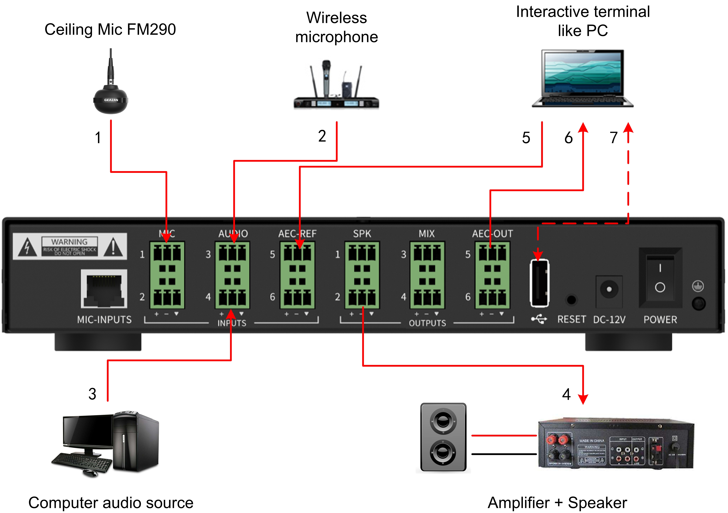
Pic. 31 Single Wired Microphone MC988-M1 Diagram

The device wiring is connected through the interface on the rear panel.

- 1 ceiling microphone FM290 is connected to the audio processor MIC 1 or MIC 2 input interface, in order to pick up the voice of local teachers and students.

- External wireless microphone (optional) can connect to audio processor AUDIO 3 input interface.

- The computer audio source output is connected to the audio processor AUDIO 4 input interface.

- SPK 1 - 2 output interface is connected to the power amplifier, and then the power amplifier is connected to the speaker for playing the remote audio signal.

- There are two ways to connect with the interactive terminal.

- Phoenix connector: the interactive terminal like PC audio output is connected to the audio processor AEC-REF input to provide audio signals from the remote classroom. The audio processor AEC-OUT output is connected to the interactive terminal audio input, and sends the sound picked up by the microphone and the computer sound source to the far end.

- USB connection: If the interactive terminal supports USB, you can also directly connect the audio processor and the USB terminal of the interactive terminal through a USB cable, as shown by the dotted line in the above diagram.

Please note, the above connection is one of two options.

    - Device List
Table 31 Single Wired Microphone Device List

No. | Model No. | Name | QTY | Description
1 | MC220E | Audio Processor | 1 | Enhanced interactive audio processor.
2 | FM290 | Spherical Omnidirectional Microphone | 1 | Microphone, a high-performance full-range pickup device, designed for classroom normalized recording and remote interactive scenarios.

  - Solution 2: Double Wired Microphones MC988-M2
    - Solution 2 Diagram
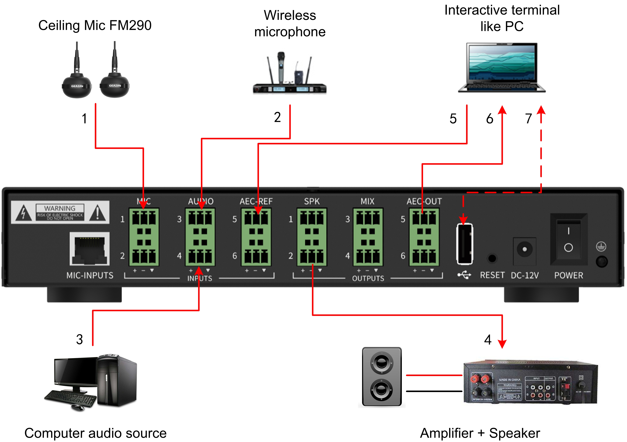
Pic. 32 Double Wired Microphones MC988-M2 Diagram

The device wiring is connected through the interface on the rear panel.

- 2 ceiling microphones FM290 are connected to the audio processor MIC 1 or MIC 2 input interface, in order to pick up the voice of local teachers and students.

- External wireless microphone (optional) can connect to audio processor AUDIO 3 input interface.

- The computer audio source output is connected to the audio processor AUDIO 4 input interface.

- SPK 1 - 2 output interface is connected to the power amplifier, and then the power amplifier is connected to the speaker for playing the remote audio signal.

- There are two ways to connect with the interactive terminal.

- Phoenix connector: the interactive terminal like PC audio output is connected to the audio processor AEC-REF input to provide audio signals from the remote classroom. The audio processor AEC-OUT output is connected to the interactive terminal audio input, and sends the sound picked up by the microphone and the computer sound source to the far end.

- USB connection: If the interactive terminal supports USB, you can also directly connect the audio processor and the USB terminal of the interactive terminal through a USB cable, as shown by the dotted line in the above diagram.

Please note, the above connection is one of two options.
    - List
Table 32 Double Wired Microphones Device List

No. | Model No. | Name | QTY | Description
1 | MC220E | Audio Processor | 1 | Enhanced interactive audio processor.
2 | FM290 | Spherical Omnidirectional Microphone | 2 | Microphone, a high-performance full-range pickup device, designed for classroom normalized recording and remote interactive scenarios.

- Device Introduction
  - Audio Processor MC220E
    - MC220E Features
- 1 microphone input network interface can be connected to 1 wireless microphone and 2 wired microphones.
- 2 balanced microphone inputs, support 48V phantom power supply and Phoenix connector.
- 4 balanced line inputs, Phoenix connector.
- 6 balanced line outputs, Phoenix connector.
- 1 USB 2.0 A interface has data transmission function.
- Full-band full-duplex adaptive echo cancellation technology.
- Dynamic adaptive noise reduction up to 18dB.
- Smart sound mixing and microphone selection technology.
- Sampling frequency 48kHz, A/D-D/A in 24-bit.
- Adaptive algorithm, select different functions simply by dial switch.
- Independent input and output volume adjustment knob.
- Support USB, network cable and wireless transmission of audio signals.
- Support wireless and wired microphone avoidance setting and give priority to the sound of wireless microphone when both microphones have sound inputs.

    - Audio Processor MC220E Port Instruction
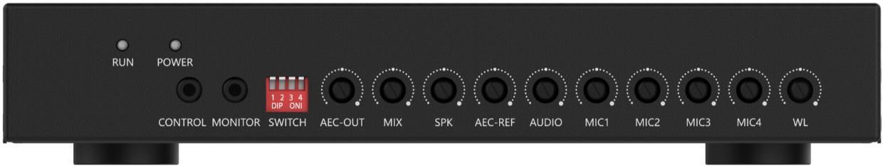
Pic. 41 Front Panel of MC220E

Table 41 MC220E Front Panel Instruction
Interface, indicator and knobs | Function description
RUN | Operation indicator, slow flashing indicates normal operation.
POWER | Power indicator, power on indicator on.
CONTROL | Internal debugging port, not for customer usage.
MONITOR | 3.5mm monitoring headphone jack.
SWITCH | 4 DIP switches.
AEC-OUT | AEC-OUT output volume knob.
MIX | MIX output volume knob.
SPK | SPK output volume knob.
AEC-REF | Far-end reference signal input volume knob.
AUDIO | Line input volume knob.
MIC1 | MIC1 Microphone input volume knob.
MIC2 | MIC2 Microphone input volume knob.
MIC3 | MIC3 Microphone input volume knob.
MIC4 | MIC4 Microphone input volume knob.
WL | Volume knob of wireless microphone input.

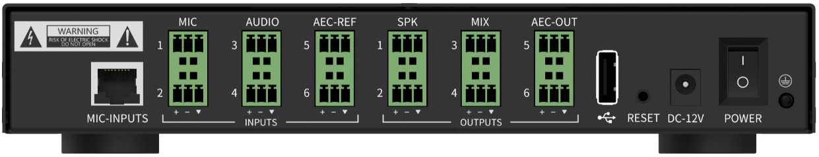
Pic. 42 Rear Panel of MC220E

Table 42 MC220E Rear Panel Instruction
Interface, indicator and knobs | Function description
MIC-INPUTS | Microphone input network interface, connect to wired microphones of MIC3 & MIC4 and wireless microphone through network cable.
MIC | 2 microphone input interfaces (MIC1 & MIC2), phoenix connector.
AUDIO | 2 line input interfaces, usually connect to local audio input such as DVD or computer, phoenix connector.
AEC-REF | 2 line input interfaces, usually used in interactive and distance learning, receiving signals from far-end, called a reference signal. Phoenix connector.
SPK | 2 amplifier line output interfaces, phoenix connector.
MIX | 2 recording line output interfaces, phoenix connector.
AEC-OUT | 2 line output interfaces, usually used in interactive and distance learning, output local audio signal and the signal picked up by local microphones and transmit them to the far end. Phoenix connector.
USB | 1 USB 2.0 A interface has data transmission function.
RESET | Restore factory settings button, long press the device for 3 seconds to restart and restore factory settings.
DC-12V | Power port.
POWER | Power switch.

    - Audio Processor MC220E Technical Specification
Table 43 MC220E Technical Specification
Parameter | Value
Frequency Response (20Hz~20kHz @ +4dBu):
Microphone Channel | +0/-2dB
Line Input Channel | +0/-0.5dB
THD +N (1kHz @ +4dBu):
Microphone Channel | < 0.009%
Line Input Channel | < 0.007%
Equivalent Noise | < -84dBu(20Hz~20kHz@22dB)
Dynamic Range | > 105dB(20Hz~20kHz@0dB)
Maximum Input Balance
Microphone Channel | -2dBu
Line Input Channel | 20dBu
Maximum Output Balance | 20dBu
Maximum Gain
Microphone Channel | 50dB
Line Input Channel | 0dB
Input Impedance
Microphone Channel | 2.2KΩ
Line Input Channel | 20KΩ
Output Impedance | 400Ω
Sampling Frequency | 48kHz
A/D-D/A Converter | 24-bit
Phantom Power | DC 48V

  - Spherical Microphone FM290
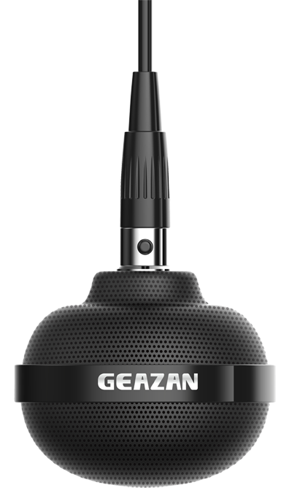
Pic. 43 Spherical Microphone FM290

FM290 is a high-performance full-coverage pickup microphone developed by Shenzhen Geazan for classroom normalized recording & playback and remote interactive scenarios. A single FM290 has a pickup radius of 8 meters, and two FM290s can cover a classroom or conference room with an area of more than 120 square meters. Lecturers or conference speakers can speak anywhere within 2-8 meters from the omnidirectional microphone FM290 without affecting the pickup effect.

FM290 has a wide collection frequency response, keep sound balanced, and high fidelity. It has an excellent sense of hearing. Due to the use of advanced field effect techniques, FM290 has high sensitivity and very low noise, thus achieving a high signal-to-noise ratio.

FM290 is widely used in classrooms and conference rooms, and it is a model product of omnidirectional microphone in the industry.

Table 44 FM290 Technical Specification
Parameter | Value
Transducer Type | Φ24 back electret condenser
Circuit Characteristics | JFET impedance transformation; electronic balance
Directionality | Omnidirectional
Frequency Response | 50Hz-20kHz
Sensitivity | -44±3dB (0dB=1V/Pa@1kHz)
Rated Output Impedance | 2.2kΩ
Minimum Load Impedance | 1kΩ
SNR | 75dB (S:(f=1kHz@1Pa) N:(A-Weighted curve))
Maximum Sound Pressure Level | 115dB (f=1kHz, THD<1%)
Power Supply/ Current Consumption | VS=1.5V@2.2kΩ
Dynamic Range | 104dB (20Hz-20kHz@2.5kΩ)
Maximum Output Electrical Level | 1.6dBV (20Hz-20kHz, THD<1%@2.5kΩ)
Working and Storage Temperature | 0-45℃/ -20-70℃ (32-113 °F/ -4 to 158 °F)
Working and Storage Humidity | 10% - 90% (non-condensing)
Output Connection and Cable | Mini XLR-3 Male/ Twisted Shielded MIC Cable
Color | Matte black
Net Weight | 43g
Dimensions | 54x45mm

  - Microphone Input Gain Adjustment
In actual use, different microphones have different sensitivities. Therefore the audio processor provides 5 knobs for microphone input gain adjustment on the right of front panel. From left to right, corresponding to the MIC1 and MIC2 phoenix connectors on the rear panel, wired master microphne MIC3 and wired slave microphone MIC4 and wireless microphone connected through the MIC-INPUT RJ45 input port on the rear panel, see the picture below.

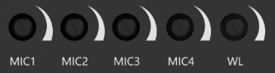
Pic. 44 Mic Input Gain Adjustment Knobs

When adjust the Gain, user can use “—” screwdriver to turn up in clockwise direction, and turn down in counterclockwise direction.

  - Line Input and Output Gain Adjustment
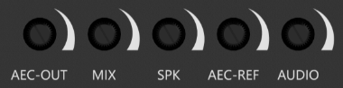
Pic. 45 Line Input and Output Gain Adjustment Knobs

There are 2 line input and 3 line output gain adjustment knobs on the left side of the microphone input adjustment knobs on the front panel of the processor. User can use “—” screwdriver to turn up in clockwise direction, and turn down in counterclockwise direction.

  - DIP Switch Introduction
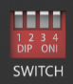
Pic. 46 DIP Switch
The front panel of the processor has a 4-digit DIP switch. DIP switch downward indicates ON and upward indicates OFF. They can control the phantom power, the echo cancellation algorithm turned on or off, and the noise suppression related parameters.

Table 45 DIP Switch Introduction
DIP SWITCH status | Function description
Switch 1 “ON” | 2 microphone inputs phantom power turned on
Switch 1 “OFF” | 2 microphone inputs phantom power turned off
Switch 2 “ON” | AEC “aggressive”
Switch 2 “OFF” | AEC “soft”
Switch 3 & Switch 4 both “ON” | Noise suppression 18dB
Switch 3 & Switch 4 both “OFF” | Noise suppression turned off
Switch 3 “OFF”, Switch 4 “ON” | Noise suppression 15dB
Switch 3 “ON”, Switch 4 “OFF” | Noise suppression 12dB

  - Wire Connection
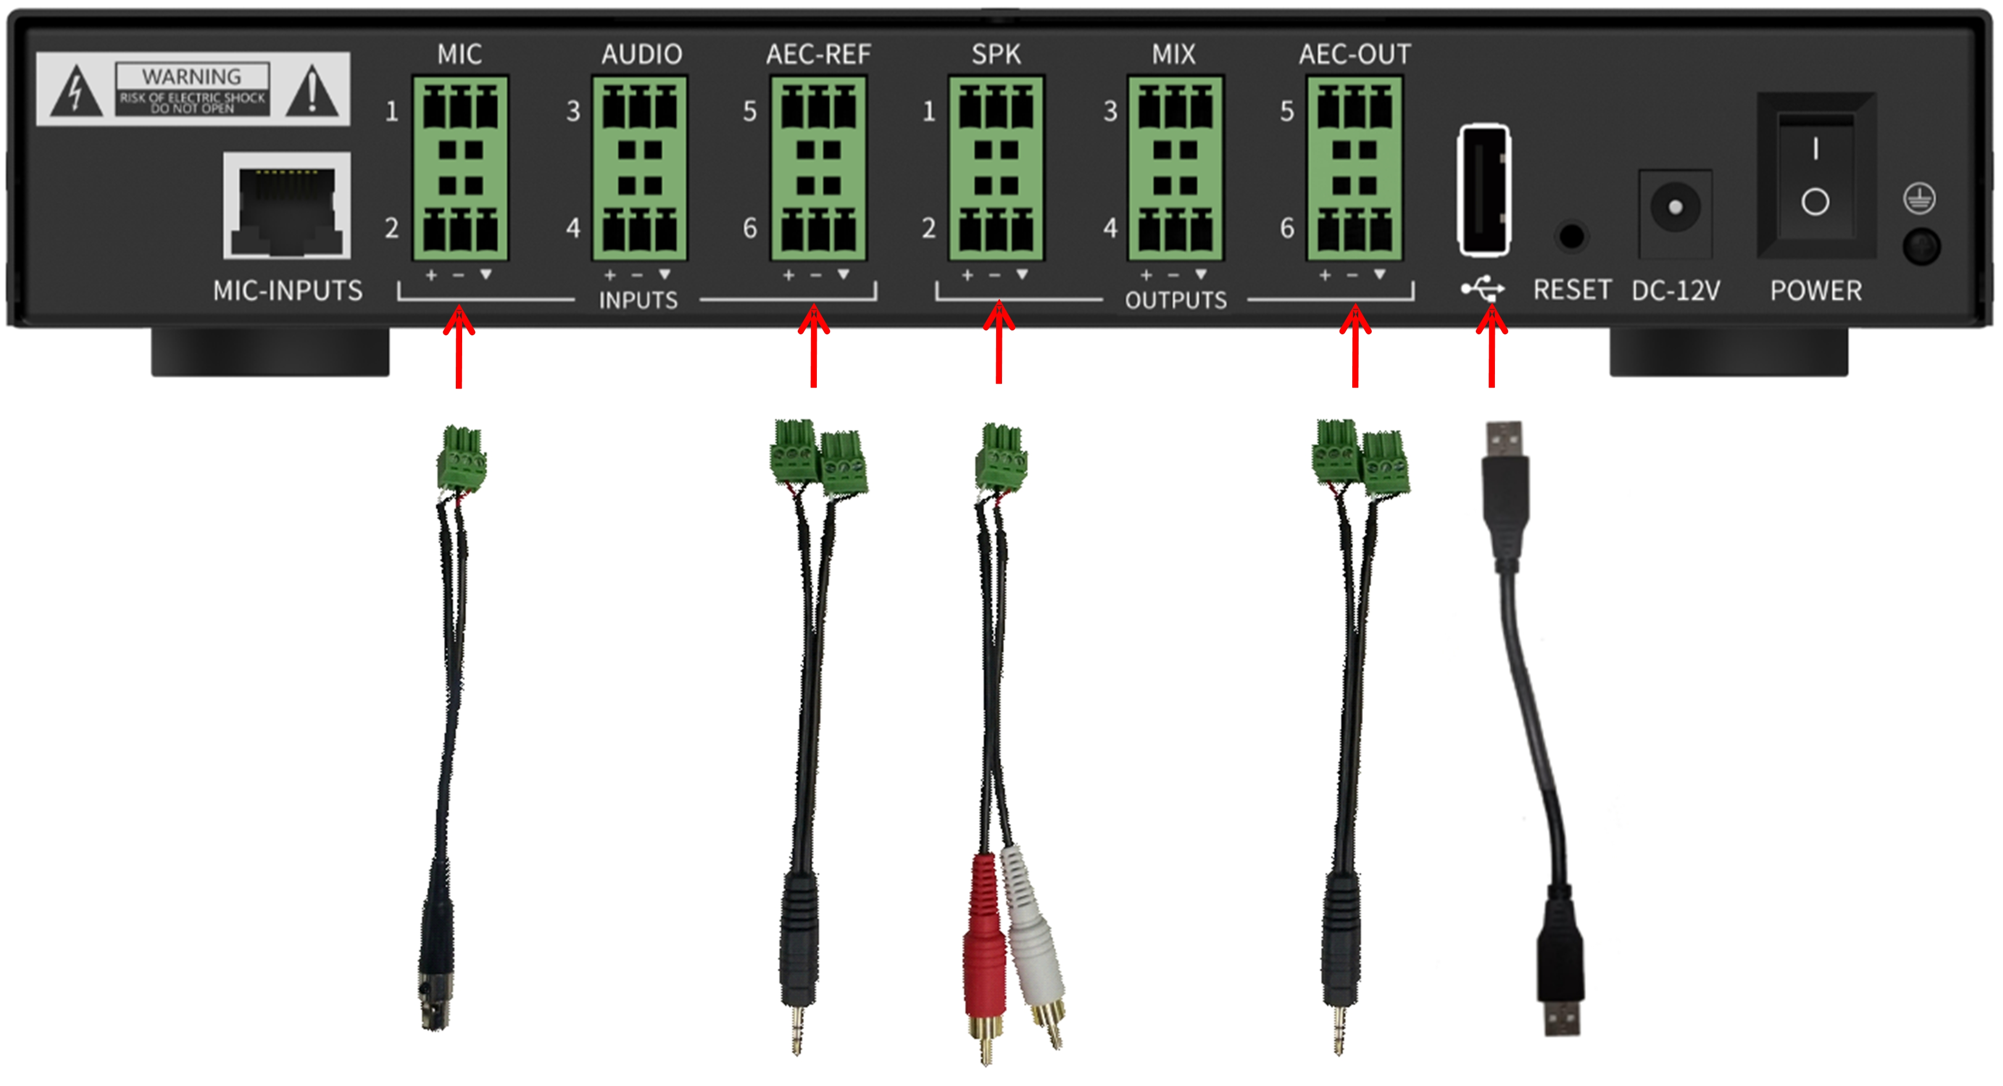
Pic. 47 Wire Connection

See above wire connection picture. Devices will be connected through those cables.
  - For MIC input, need XLR (Canon head connector) to phoenix connector cable.
  - For AEC-REF input & AEC-OUT output, need 3.5mm audio cable to phoenix connector.
  - For SPK output, need RCA cable to phoenix connector.
  - For USB port, need USB A to USB A cable.

Please note, the above items 2 and 4 connection is one of two options for AEC function.

- FAQ
  - Output without Sound
- Check the power indicator of processor on or not.
- Check the RUN indicator slow flashing or not.
- Check the input/ output interface connection right or not.
- Check the signal of Mic Input source and Line Input source normal or not.
- Check the knobs of the audio processor have been turned to the "off" status or not, and if all the knobs are turned to 12 o'clock, the sound will appear.

  - The Output Sound Has Current Noise
  - Check the audio cable is connected correctly or not.
  - Check if the audio cable is shielded, if there is a wireless base station or strong power control near the site.
  - If only the MIC sound has noise, check the network cable is Category 6 with shielded or not.
  - Check the input signal level is oversize or not.
  - Check the USB connector is fully inserted or not.

  - Remote Interactive Echo cannot Cancel
- Check the remote-end reference signal is connected right or not.
- Check the power amplifier and speakers are directly connected to the audio processor or not.
- Check the far-end reference signal level is normal or not.
- Check if the far-end AEC-REF input audio source is the same as the sound played by local speakers, and if there is broken sound or distortion when the local speaker is playing.

