

**RC0606V2 HANDBOOK**

|  |  |
| --- | --- |
|  |  |
|  |  |

© 2022 Shenzhen Geazan Technology Co., Ltd. All rights reserved.

Contents

1 Introduction 2

1.1 What does this handbook do? 2

1.2 Overview of the audio processor 2

2 Connection and Usage 3

3 Panel operation 4

4 FAQ 5

4.1 Output without Voice 5

4.2 Current Noise in Output Voice 5

4.3 Remote Interactive Echo cannot Cancel? 5

# Introduction

## What does this handbook do?

The handbook will help users how to fix and use the interactive type 6-in/6-out audio processor, the readers will be engineers who participate in site operation and test.

## Overview of the audio processor

The interactive type RC0606V2 is a compact digital audio processor designed for both local classroom recording and distance education by GEAZAN. Audio processor RC0606V2 uses core audio algorithms including adaptive noise reduction, smart mixing, and voice tracking etc., additionally supports various audio signal processing modules and signal routing allocation, which could be designed through PC software by users.

# Connection and Usage

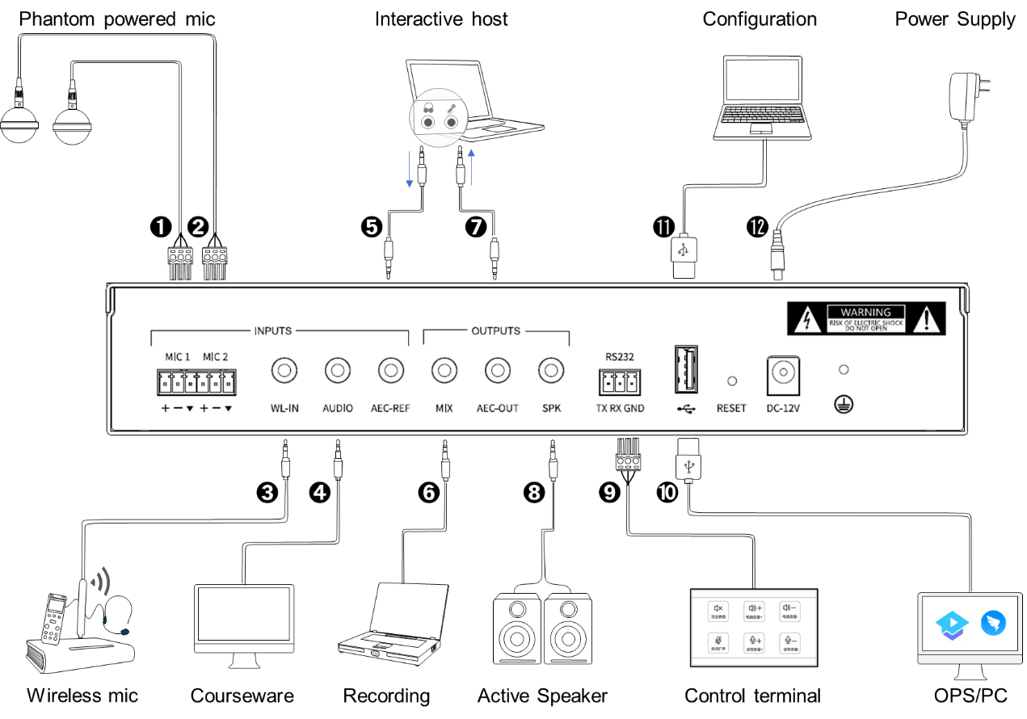

Devices will be connected through the interfaces in the rear panel, details are below:

1-2. MIC: Two balanced microphone input interfaces, supporting 48V phantom power supply, suitable for accessing omni-directional and directional microphone.

3. WL-IN: 3.5mm wireless microphone input interface. It can be connected to a wireless microphone.

4. AUDIO: 3.5mm line input interface. It can be connected to local sound source input, such as DVD, computer, etc.

5. AEC-REF: 3.5mm line input interface. It can access the signal from the remote end in interactive and distance teaching, that is, reference signal input.

6. MIX: 3.5mm line output interface. It can be connected to external recording equipment.

7. AEC-OUT: 3.5mm line output interface. The processed audio signal is output to the far end.

8. SPK: 3.5mm line output interface. It can be connected to an external power amplifier or an active speaker.

9. RS232: Serial control interface. It can be connected to the external control terminal.

10-11. USB2.0 type A interface: It supports bidirectional audio data transmission, and can also be connected with a computer for visual software configuration.

12. Power interface: DC-12V.

# Panel operation

The front panel of the audio processor can perform operations such as power switch, mic volume adjustment and operation state observation.



1. POWER switch

2. POWER indicator, power switch indicator, always on after power on.

3. RUN indicator, operation status indication, slow flashing indicates normal operation.

4. MIC1 knob, mic1 volume adjustment knob.

5. MIC2 knob, mic2 volume adjustment knob.

After the equipment is powered on, the POWER light is normally on and the RUN light flashes slowly.

# FAQ

## Output without Voice

1. Check the POWER indicator of processor on or not.

2. Check the RUN indicator slow flashing or not.

3. Check the input/output interface connection right or not.

4. Check the signal of Mic Input source and Line Input source normal or not.

## Current Noise in Output Voice

1. Does audio patch cord make right?

2. Does the audio wire need the shield wire to connect?

3. Does the input signal level oversize?

## Remote Interactive Echo cannot Cancel?

1. Check the remote-end reference signal access right or not.

2. Do Amplifier and speaker access connect to the audio processor?

3. Check the remote-end reference signal level right or not?

4. Is the remote-end input audio source the same at the local voice in the speaker (Does the speaker crack or distort)?