GEAZAN Enhanced Interactive
Digital Audio Processor
(Model No.: MC220E)

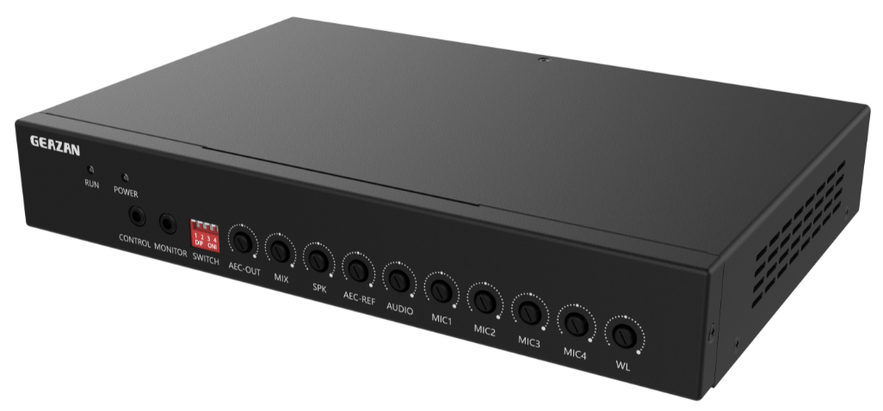

Overview
MC220E is a far-talk echo cancellation digital audio processor specially developed by GEZAN for educational normalized recording and remote interactive systems. MC220E provides 1 microphone input network interface (can be connected to 1 wireless microphone and 2 wired microphones), 2 balanced microphone inputs, 4 line inputs, 6 line outputs, 1 USB 2.0 A interface and 1 reset button.

MC220E has embedded digital audio algorithms such as adaptive echo cancellation, adaptive noise suppression and intelligent mixing which makes MC220E have a very high signal-to-noise ratio and the output sound is full and clear.

According to the design ideas of GEAZAN’s smart, configuration-free and simple to use, MC220E can achieve excellent remote interactive audio effects just through a simple connection. It can meet the high-quality audio needs of distance education and web conferencing.

Features
- 1 microphone input network interface can be connected to 1 wireless microphone and 2 wired microphones.
- 2 balanced microphone inputs, support 48V phantom power supply and Phoenix connector.
- 4 balanced line inputs, Phoenix connector.
- 6 balanced line outputs, Phoenix connector.
- 1 USB 2.0 A interface has data transmission function.
- Full-band full-duplex adaptive echo cancellation technology.
- Dynamic adaptive noise reduction up to 18dB.
- Smart sound mixing and microphone selection technology.
- Sampling frequency 48kHz, A/D-D/A in 24-bit.
- Adaptive algorithm, select different functions simply by dial switch.
- Independent input and output volume adjustment knob.
- Support USB, network cable and wireless transmission of audio signals.
- Support wireless and wired microphone avoidance setting and give priority to the sound of wireless microphone when both microphones have sound inputs.

Front
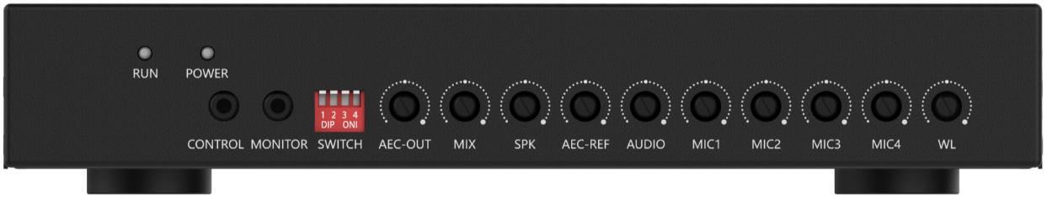

Front Panel Instruction
Interface, indicator and knobs | Function description
RUN | Operation indicator, slow flashing indicates normal operation.
POWER | Power indicator, power on indicator on.
CONTROL | Internal debugging port, not for customer usage.
MONITOR | 3.5mm monitoring headphone jack.
SWITCH | 4 DIP switches.
AEC-OUT | AEC-OUT output volume knob.
MIX | MIX output volume knob.
SPK | SPK output volume knob.
AEC-REF | Far-end reference signal input volume knob.
AUDIO | Line input volume knob.
MIC1 | MIC1 Microphone input volume knob.
MIC2 | MIC2 Microphone input volume knob.
MIC3 | MIC3 Microphone input volume knob.
MIC4 | MIC4 Microphone input volume knob.
WL | Volume knob of wireless microphone input.

Rear
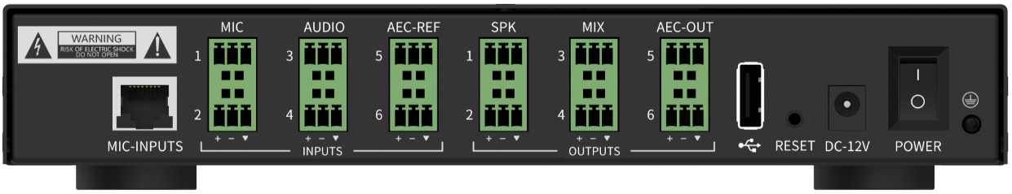

Rear Panel Instruction
Interface, indicator and knobs | Function description
MIC-INPUTS | Microphone input network interface, connect to wired microphones of MIC3 & MIC4 and wireless microphone through network cable.
MIC | 2 microphone input interfaces (MIC1 & MIC2), phoenix connector.
AUDIO | 2 line input interfaces, usually connect to local audio input such as DVD or computer, phoenix connector.
AEC-REF | 2 line input interfaces, usually used in interactive and distance learning, receiving signals from far-end, called a reference signal. Phoenix connector.
SPK | 2 amplifier line output interfaces, phoenix connector.
MIX | 2 recording line output interfaces, phoenix connector.
AEC-OUT | 2 line output interfaces, usually used in interactive and distance learning, output local audio signal and the signal picked up by local microphones and transmit them to the far end. Phoenix connector.
USB | 1 USB 2.0 A interface has data transmission function.
RESET | Restore factory settings button, long press the device for 3 seconds to restart and restore factory settings.
DC-12V | Power port.
POWER | Power switch.

Specifications
Parameter | Value
Frequency Response (20Hz~20kHz @ +4dBu):
Microphone Channel | +0/-2dB
Line Input Channel | +0/-0.5dB
THD +N (1kHz @ +4dBu):
Microphone Channel | < 0.009%
Line Input Channel | < 0.007%
Equivalent Noise | < -84dBu(20Hz~20kHz@22dB)
Dynamic Range | > 105dB(20Hz~20kHz@0dB)
Maximum Input Balance
Microphone Channel | -2dBu
Line Input Channel | 20dBu
Maximum Output Balance | 20dBu
Maximum Gain
Microphone Channel | 50dB
Line Input Channel | 0dB
Input Impedance
Microphone Channel | 2.2KΩ
Line Input Channel | 20KΩ
Output Impedance | 400Ω
Sampling Frequency | 48kHz
A/D-D/A Converter | 24-bit
Phantom Power | DC 48V

Dimensions
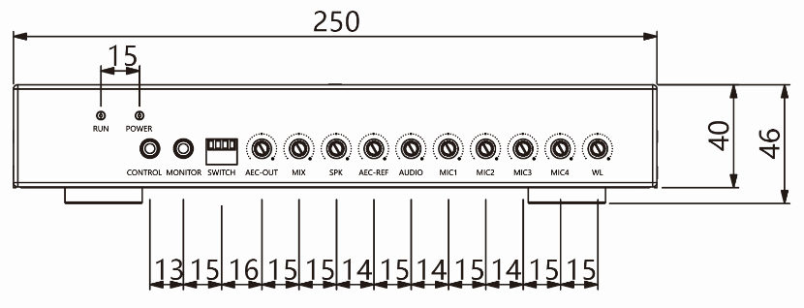
FRONT

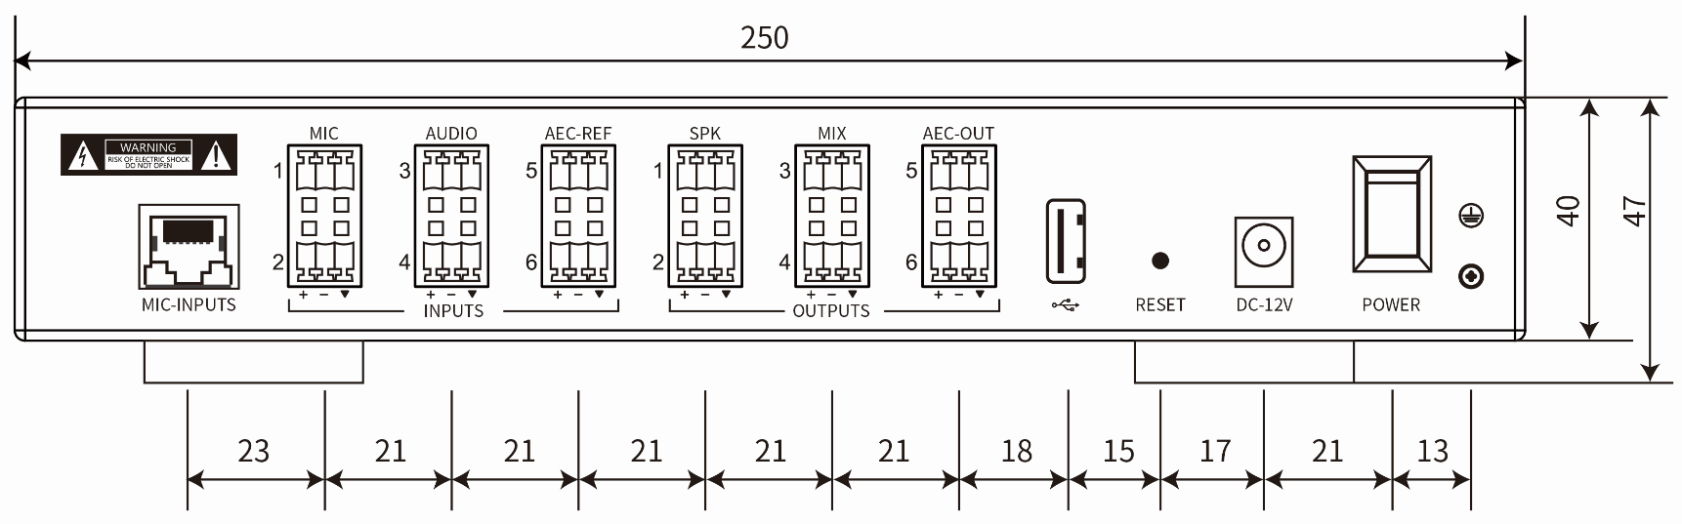
REAR

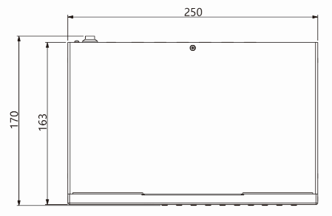
TOP

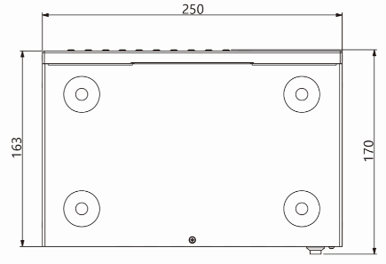
BOTTOM

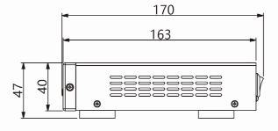
SIDE

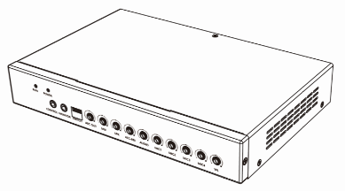
PERSPECTIVE

