GEAZAN 6-Channel Interactive
Digital Audio Processor
(Model No.: RC0606V2)

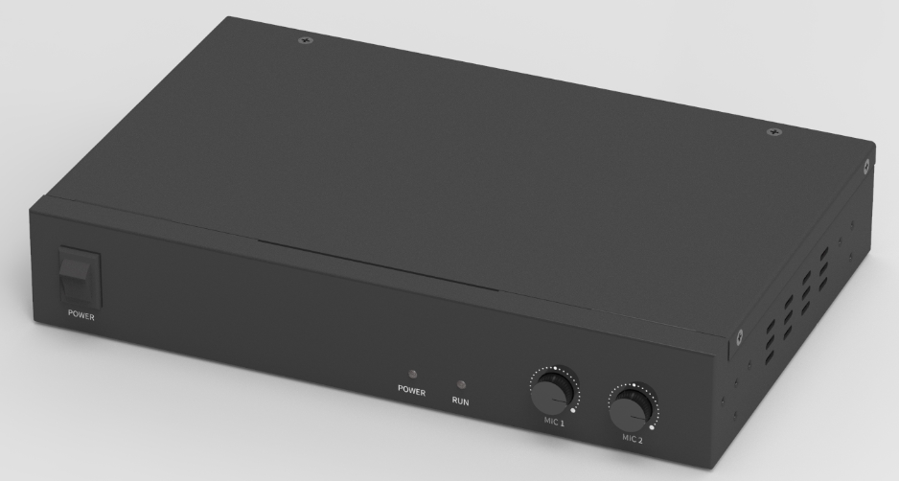

Overview
RC0606V2 is a compact 6-channel interactive digital audio processor designed by GEAZAN. It adopts adaptive echo cancellation, adaptive noise reduction, and smart mixing technology and has an extremely high SNR reproducing a clear and natural sound. RC0606V2 is equipped with GEAZAN's exquisite and compact spherical omnidirectional microphone, the system perfectly picks up the sound and cancels echoes in a room size of 100m2.
According to the design ideas of GEAZAN’s smart, configuration-free and simple to use, RC0606V2 adopts adaptive algorithm and is ready to use after installation. It is convenient for engineers to install and debug, and also meets the needs of normalized interaction and audio collection of recording system.

Highlights
- More than 5m radius pick-up sounds each mic, cover full classroom in 2 mics.
- Suitable for normalized recording and playback classrooms or conference rooms with interactive needs.
- Easy installation, reduced project deployment time.
- 1 USB audio interface can be integrated into the computer as a sound card.
- Visual control software simplifies panel operation.

Features
- 2 Balanced mic inputs, support 48V phantom power supply, using Phoenix terminal interface.
- 1 external wireless microphone input, using 3.5mm earphone interface.
- 2 line inputs, using 3.5mm earphone interface.
- 3 line outputs, using 3.5mm earphone interface.
- 1 USB2.0 A interface, supports bidirectional audio data transmission or visual software configuration.
- 2 microphone input volume adjustment knobs.
- 1 RS-232 serial port, which can be connected to the control terminal.
- 1 RESET key to restore the default factory settings.

Connection and Usage
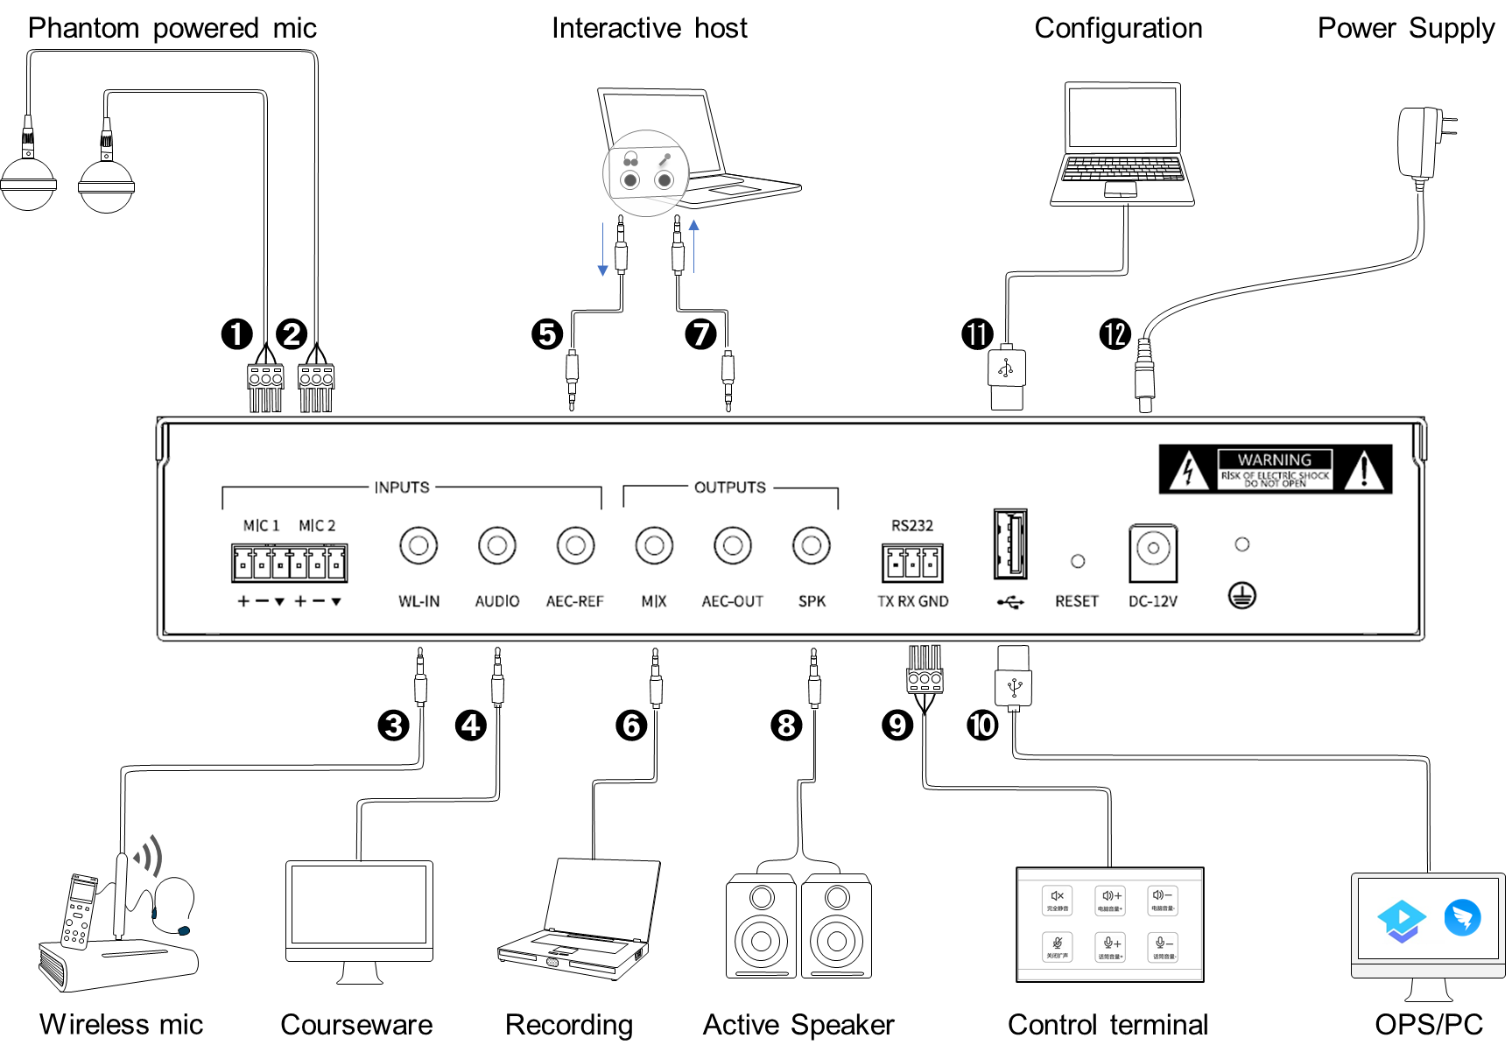
Devices will be connected through the interfaces in the rear panel, details are below:
1-2. MIC: Two balanced microphone input interfaces, supporting 48V phantom power supply, suitable for accessing omni-directional and directional microphone.
3. WL-IN: 3.5mm wireless microphone input interface. It can be connected to a wireless microphone.
4. AUDIO: 3.5mm line input interface. It can be connected to local sound source input, such as DVD, computer, etc.
5. AEC-REF: 3.5mm line input interface. It can access the signal from the remote end in interactive and distance teaching, that is, reference signal input.
6. MIX: 3.5mm line output interface. It can be connected to external recording equipment.
7. AEC-OUT: 3.5mm line output interface. The processed audio signal is output to the far end.
8. SPK: 3.5mm line output interface. It can be connected to an external power amplifier or an active speaker.
9. RS232: Serial control interface. It can be connected to the external control terminal.
10-11. USB2.0 type A interface: It supports bidirectional audio data transmission, and can also be connected with a computer for visual software configuration.
12. Power interface: DC-12V.

Appearance and Interfaces
Front
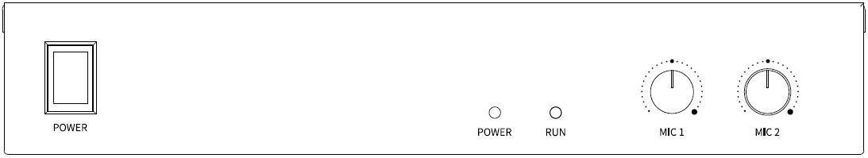

Instructions for Front Panel
Interface, Indicator and Knobs | Function Description
POWER key | Power switch.
POWER indicator | The power indicator remains on after power on.
RUN indicator | The operation indicator flashes slowly, indicating normal operation.
MIC1 knob | Mic1 input volume adjustment knob.
MIC2 knob | Mic2 input volume adjustment knob.

Rear
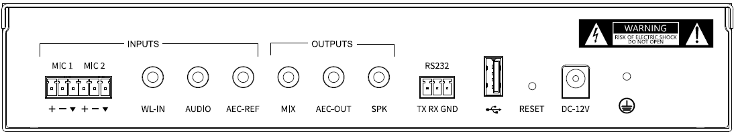

Instructions for Rear Panel
Interface, Indicator and Knobs | Function Description
MIC (1-2) | Two balanced microphone input interfaces, supporting 48V phantom power supply.
WL-IN | 3.5mm wireless microphone input interface.
AUDIO | 3.5mm line input interface, for the local audio source, such as DVD, computer, etc.
AEC-REF | 3.5mm line input interface to access the signal from the remote end in interactive and distance teaching.
MIX | 3.5mm line output interface, external recording equipment can be connected.
AEC-OUT | 3.5mm line output interface to output the processed audio signal to the far end.
SPK | 3.5mm line output interface, which can be connected to power amplifier or active speaker for local sound reinforcement output.
RS232 | The serial control interface, can be connected to the control terminal.
USB2.0 type A interface | Support bidirectional audio data transmission or visual software configuration.
RESET | Restore the factory configuration key. Long press 3s to restart the device and restore the factory configuration.
Power interface | DC-12V.

Specifications
Parameter | Value
Frequency Response (20Hz~16kHz @ +4dBu):
Microphone Channel | +0/-2dB
Line Input Channel | +0/-0.5dB
THD +N (1kHz @ +4dBu):
Microphone Channel | < 0.009%
Line Input Channel | < 0.007%
Equivalent Noise | < -84dBu(20Hz~16kHz@22dB)
Dynamic Range | > 105dB(20Hz~16kHz@0dB)
Maximum Input Balance
Microphone Channel | -2dBu
Line Input Channel | 20dBu
Maximum Output Balance | 20dBu
Maximum Gain
Microphone Channel | 50dB
Line Input Channel | 0dB
Input Impedance
Microphone Channel | 2.2KΩ
Line Input Channel | 20KΩ
Output Impedance | 400Ω
Phantom Power | DC 48V
Size | 250mm×165mm×45mm

