**User Manual**

**CHC2**

**18G In-line HDMI Controller with**

**Auto Display Control**

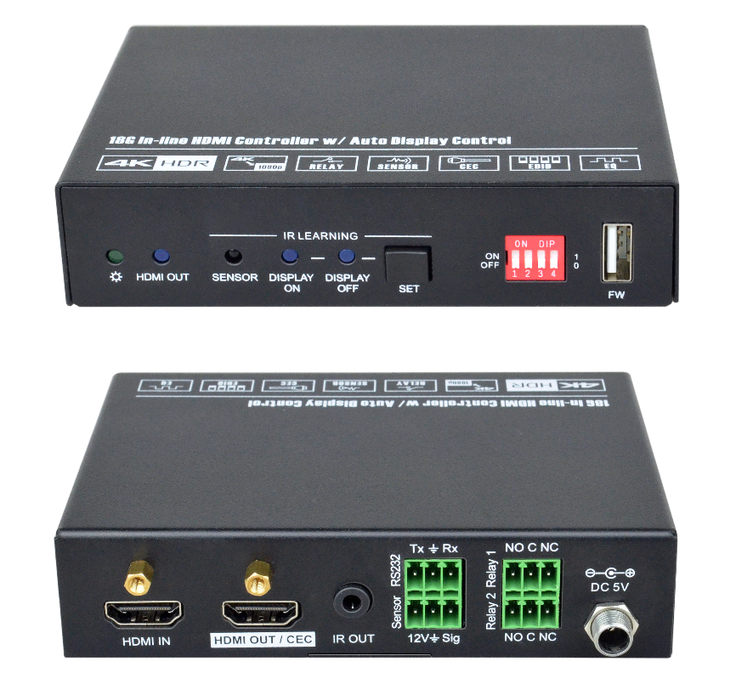

**All Rights Reserved**

**Version: CHC2_2019V1.1**

**Preface**

Read this user manual carefully before using the product. Pictures shown in this manual are for reference only. Different models and specifications are subject to real product.

This manual is only for operation instruction, please contact the local distributor for maintenance assistance. The functions described in this version were updated till March, 2019. In the constant effort to improve the product, we reserve the right to make functions or parameters changes without notice or obligation. Please refer to the dealers for the latest details.

**FCC Statement**

This equipment generates, uses and can radiate radio frequency energy and, if not installed and used in accordance with the instructions, may cause harmful interference to radio communications. It has been tested and found to comply with the limits for a Class B digital device, pursuant to part 15 of the FCC Rules. These limits are designed to provide reasonable protection against harmful interference in a commercial installation.

Operation of this equipment in a residential area is likely to cause interference, in which case the user at their own expense will be required to take whatever measures may be necessary to correct the interference.

Any changes or modifications not expressly approved by the manufacture would void the user’s authority to operate the equipment.

  

**SAFETY PRECAUTIONS**

To ensure the best performance from the product, please read all instructions carefully before using the device. Save this manual for further reference.

* Unpack the equipment carefully and save the original box and packing material for possible future shipment.
* Follow basic safety precautions to reduce the risk of fire, electrical shock and injury to persons.
* Do not dismantle the housing or modify the module. It may result in electrical shock or burn.
* Using supplies or parts not meeting the products’ specifications may cause damage, deterioration or malfunction.
* Refer all servicing to qualified service personnel.
* To prevent fire or shock hazard, do not expose the unit to rain, moisture or install this product near water.
* Do not put any heavy items on the extension cable in case of extrusion.
* Do not remove the housing of the device as opening or removing the housing may expose you to dangerous voltage or other hazards.
* Install the device in a place with fine ventilation to avoid damage caused by overheat.
* Keep the module away from liquids.
* Spillage into the housing may result in fire, electrical shock, or equipment damage. If an object or liquid falls or spills on to the housing, unplug the module immediately.
* Do not twist or pull by force ends of the optical cable. It can cause malfunction.
* Do not use liquid or aerosol cleaners to clean this unit. Always unplug the power to the device before cleaning.
* Unplug the power cord when left unused for a long period of time.
* Information on disposal for scrapped devices: do not burn or mix with general household waste, please treat them as normal electrical wastes.

**Table of Contents**

1. Product Introduction 1

1.1 Features 1

1.2 Package List 1

2. Technical Specification 2

3. Panel Description 3

3.1 Front Panel 3

3.2 Rear Panel 4

4. System Connection 5

4.1 Usage Precaution 5

4.2 System Diagram 5

5. DIP Switch Operation 6

5.1 EDID Management 6

5.2 HDCP Mode 8

6. System Control Setting 9

6.1 RS232 Command Setting 10

6.1.1 RS232 Control Software 10

6.1.2 Trigger Method Setting 11

6.1.3 CEC Control Setting 12

6.1.4 RS232 Control Setting 12

6.1.5 IR Control Setting 14

6.1.6 Relay Control Setting 15

6.1.7 System Command 16

6.2 Front Panel IR Learning 16

7. Panel Drawing 17

8. Troubleshooting & Maintenance 18

9. Customer Service 19

# Product Introduction

Thanks for choosing the CHC2 18G In-line HDMI Controller, which is designed for automatic system control and HDMI signal extension in small meeting rooms and huddle spaces. The controller supports three system trigger methods, IR signal, video signal (5V or TMDS). It automatically triggers CEC commands, pre-loaded RS232 and IR commands to turn on or off display, and relay control to rise and fall the projection screen. It supports video resolution up to 4K@60Hz 4:4:4 HDR 10 and Dolby Vision, and features 4K to 1080P down-scaling for compatibility with 1080P display. Besides passing EDID information from the display, there are multiple built-in EDID settings can be selected by the 4-pin DIP switch on the front panel. In addition, the controller supports CEC control, RS232 control, IR learning and relay control.

## Features

* Supports up to 4Kx2K@60Hz 4:4:4 HDR10 and Dolby Vision, HDCP 2.2 compliant.
* HDCP pass-through or converted to HDCP 1.4 for better compatibility.
* Supports 4K to1080P down-scaling.
* Comprehensive EDID management with 8 EDID Options for various application.
* Automation display control via CEC, RS232 and IR.
* Contact Closure input for connections with a variety of devices, such as sensor and switch.
* Relay control for device like projection screen.
* Built-in signal equalizer, provides capability to use longer range HDMI cable.

## Package List

|  |  |
| --- | --- |
| * 1x 18G In-line HDMI Controller | * 2x Mounting Ears with 4 Screws |
| * 4x Plastic Cushions | * 3x 3-pin Terminal Blocks |
| * 1x RS232 Cable (3-pin to DB9) | * 1x Power Adapter (5V DC 1A) |
| * 1x User Manual |  |

***Note:*** *Please contact your distributor immediately if any damage or defect in the components is found.*

# Technical Specification

|  |  |
| --- | --- |
| **Video Input** | |
| Input | (1) HDMI IN |
| Input Connector | (1) Female type-A HDMI |
| Input Video Resolution | Up to 4Kx2K@60Hz 4:4:4 8bit |
| **Video Output** | |
| Output | (1) HDMI OUT/CEC |
| Output Connector | (1) Female type-A HDMI |
| Output Video Resolution | Up to 4Kx2K@60Hz 4:4:4 8bit |
| **Control** | |
| Control | (1) SET Button, (1) 4-pin DIP Switch, (1) FW, (1) IR OUT,  (1) RS232, (1) Sensor, (2) Relay (1~2) |
| Control Connector | (1) Type-A USB, (1) 3.5mm mini jack, (4) 3-pin terminal blocks |
| **General** | |
| HDMI Standard | 2.0 |
| HDCP Version | 2.2 |
| HDCP Pass-through | Supported |
| CEC Control | Supported |
| Hot-plug | Supported |
| Bandwidth | 18Gbps |
| HDMI Cable Length | 1080P@60Hz ≤ 33 feet (10 meters),  4K@60Hz ≤ 16 feet (5 meters) |
| Operation Temperature | -5℃ ~ +55℃ |
| Storage Temperature | -25℃ ~ +70℃ |
| Relative Humidity | 10%-90% |
| Power Supply | Input:100V~240V AC; Output: 5V DC 1A |
| Power Consumption | 2.5W(Max) |
| Dimension (W*H*D) | 120mm x 28mm x 84mm |
| Net Weight | 305g |

***Note:*** *Please adopt high-qualified HDMI cable fully compliant with HDMI2.0 for reliable transmission and connection.*

# Panel Description

## Front Panel



1. **POWER LED: T**he LED illuminates green when power is applied.
2. **HDMI OUT LED:** The LED illuminates blue when there is HDMI signal output.
3. **SENSOR:** Built-in IR sensor to receive IR signal.
4. **DISPLAY ON LED:** The LED blinks blue when the controller is in IR learning mode, and it will illuminate blue after successfully learning the IR command.
5. **DISPLAY OFF LED:** The LED blinks blue when the controller is in IR learning mode, and it will illuminate blue after successfully learning the IR command.
6. **SET:** Press the button to enable IR learning mode. Please refer to ***chapter 6.2*** for more details.
7. 4-pin DIP switch for EDID setting and HDCP mode selection.
8. **FW:** Type-A USB port for firmware upgrade.

## Rear Panel



1. **HDMI IN:** Type-A female HDMI input port to connect HDMI source device.
2. **HDMI OUT/CEC:** Supports CEC. Type-A female HDMI output port to connect HDMI display.
3. **IR OUT:** 3.5mm mini jack to connect the IR emitter to send IR signal.
4. **RS232:** 3-pin terminal block to connect the RS232 control device (e.g. PC) or a device (e.g. projector) to be controlled by RS232 commands.
5. **Sensor:** 3-pin terminal block to connect external sensor or switch.
6. **Relay 1~2:** Two3-pin terminal blocks to connect projection screen for relay control.
7. **DC 5V:** DC connector for the power adapter connection.

# System Connection

## Usage Precaution

* Make sure all components and accessories are included before installation.
* System should be installed in a clean environment with proper temperature and humidity.
* All of the power switches, plugs, sockets, and power cords should be insulated and safe.
* All devices should be connected before power on.

## System Diagram

The following diagram illustrates typical input and output connections that can be utilized with this controller:

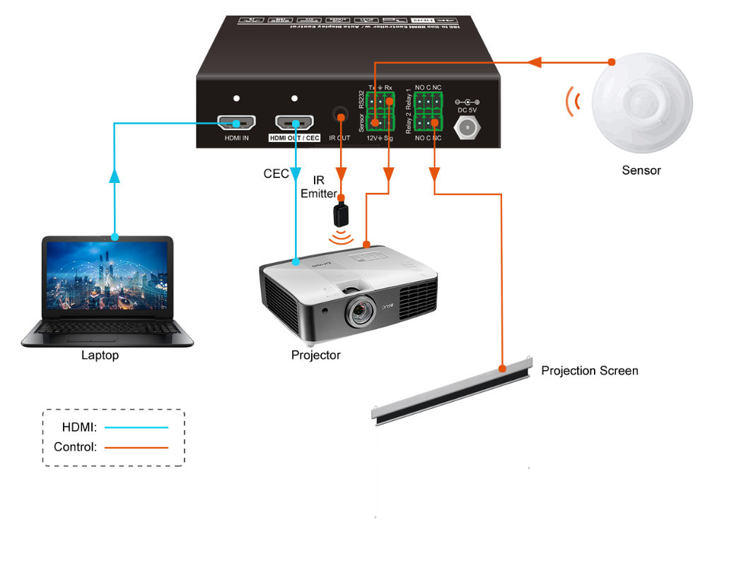

# DIP Switch Operation

## EDID Management

The Extended Display Identification Data (EDID) is used by the source device to match its video resolution with the connected display. By default, the source device obtains its EDID from the first connected display. Meanwhile, since the display with different capabilities is connected to the controller, the DIP switch on the front panel can be used to set the EDID to a fixed value to ensure the compatibility in video resolution.

The switch represents “**0**” when in the lower (**OFF**) position, and it represents “**1**” while putting the switch in the upper (**ON**) position.



Switch 1~3 are used for EDID setting. The DIP switch status and its corresponding setting are shown at the back of the product.



|  |  |  |
| --- | --- | --- |
| **Switch Status** | **Video Resolution** | **Audio Format** |
| 000 | Pass Through | |
| 001 | 1080P | 2CH |
| 010 | 1080P | Multi-CH |
| 011 | 3840x2160@30Hz HDR | 2CH |
| 100 | 3840x2160@30Hz HDR | Multi-CH |
| 101 | 3840x2160@60Hz HDR | 2CH |
| 110 | 3840x2160@60Hz HDR | Multi-CH |
| 111 | User-defined EDID (Upload the EDID by type-A USB port) | |

***Note:***

* *2CH: Supports LPCM 2CH.*
* *Multi-CH: Supports LPCM 8CH, Dolby TrueHD, DTS-HD , Dolby Digital5.1, DTS 5.1, Dolby Digital Plus.*
* **User-defined EDID Setting**

Except directly invoking the built-in EDID, the specific EDID can be customized by following the below operation process.

1. Rename the user-defined EDID as **EC_11.bin**.
2. Connect the **FW** port of the controller to the PC with USB cable, and then power on the controller, the PC will automatically detect a virtual disk named of “BOOTDISK”.
3. Double-click to open the disk, a file named of “READY.TXT” will be showed.
4. Copy the user-defined EDID to the “BOOTDISK” disk.
5. Reopen the disk to check the filename “READY.TXT” whether automatically becomes “SUCCESS.TXT”, if yes, the user-defined EDID was imported into the controller and saved as its corresponding EDID ID successfully.
6. Remove the USB cable, and then reboot the controller.
7. Now the new EDID can be invoked by setting the DIP switch status to “111”.

## HDCP Mode

Put switch 4 on “**ON**” position to select **HDCP Active** mode, or to “**OFF**” for **HDCP Passive** mode.

|  |  |  |
| --- | --- | --- |
| **Switch Status** | **Mode** | **HDCP** |
| **OFF (0)** | Passive (Default) | Automatically follows the HDCP version of source device. |
| **ON (1)** | Active | * If the input video has HDCP content, the HDCP version of HDMI output is HDCP 1.4 for broader video solution. * If the input video has no HDCP content, the HDMI output has no HDCP either. |

# System Control Setting

* ***SYSTEM ON***

*When the controller detects video signal (TMDS, 5V) or IR signal, the system will start and automatically perform the below actions at the same time.*

* *Send CEC ON to turn on display.*
* *Send RS232 ON + Delay Time (default 3s, range of 1~180s) + User-defined RS232 command to display.*
* *Send IR ON + Delay Time (default 3s, range of 1~180s) + User-defined IR command to display.*
* *Toggle the state of relay 1 as follow.*

|  |  |  |
| --- | --- | --- |
| **I/O State** | **Relay State** | |
| **NO** | **NC** |
| On (Closed) | Closed | Open |
| Off (Open) | Open | Closed |

* ***SYSTEM OFF***

*When the controller detects all input source devices are removed, or not receives IR signal within the delay time (default 10mins, range of 5mins-180mins), the system will off and automatically perform the below actions at the same time.*

* *Send CEC OFF to turn off display.*
* *Send RS232 OFF to display. The number of sending command is default 1 time, it can be set to 2 times by RS232 command.*
* *Send IR OFF to display. The number of sending command is default 1 time, it can be set to 2 times by RS232 command.*
* *Toggle the state of relay 2.*

## RS232 Command Setting

The trigger methods of *SYSTEM ON* or *SYSTEM OFF*, and CEC, RS232, IR, Relay control actions can be set by RS232 commands.

### RS232 Control Software

**Installation:** Copy the control software file to the PC which is connected to the controller.

**Uninstallation:** Delete all the control software files in corresponding file path.

Here take the software **CommWatch.exe** as example. Double-click the following icon:



The interface of the control software is shown as below:

Parameter configuration area

Monitoring area, indicates if the command sent works.

Command sending area

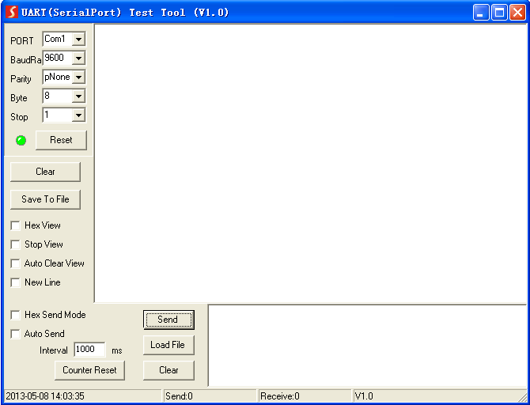

Please set the parameters of COM number, bound rate, data bit, stop bit and the parity bit correctly, then the RS232 commands can be sent in Command Sending Area.

Baud rate: 9600;

Data bit: 8;

Stop bit: 1;

Parity bit: none.

### Trigger Method Setting

|  |  |  |
| --- | --- | --- |
| **Command** | **Function** | **Feedback Example** |
| SYSONMETH[X]. | Set the trigger method to perform SYSTEM ON.   |  |  | | --- | --- | | X | Description | | 0 | Detects IR signal | | 1 | Detects HDMI video signal (default 5V, or TMDS) | | 2 | Detects IR or video signal | | SYSONMETH1. |
| SET VIDEO TRIGGER FOR SYSTEM ON! |
| SYSOFFMETH[X]. | Set the trigger method to perform SYSTEM OFF.   |  |  | | --- | --- | | X | Description | | 0 | Detects no IR signal | | 1 | Detects no HDMI video signal (default 5V, or TMDS) | | 2 | Detects no IR and video signal | | SYSOFFMETH1. |
| SET NOT DETECT VIDEO TRIGGER FOR SYSTEM OFF! |
| NOSIGDLY:[XXXXX]. | Set the system off time to xxxxx (default 10mins, range of 5mins to 180mins).  When no HDMI video signal has been detected, the system will off after the setting time. | NOSIGDLY:00300. |
| SET DETECT NOSIGNAL DELAY TIME 300S! |
| NOIRDLY:[XXXXX]. | Set the system off time to xxxxx (default 10mins, range of 5mins to 180mins).  When no IR signal has been detected, the system will off after the setting time. | NOIRDLY:00300. |
| SET DETECT NO IR DELAY TIME 300S! |
| 5VORTMDS[X]. | Set the HDMI video signal trigger condition.   |  |  | | --- | --- | | X | Description | | 0 | Detects 5V signal. | | 1 | Detects TMDS signal. | | 5VORTMDS0. |
| DETECT INPUT SOURCE USE 5V! |
| GSYSONMETH. | Report the trigger method of SYSTEM ON. | VIDEO TRIGGER FOR SYSTEM ON! |
| GSYSOFFMETH. | Report the trigger method of SYSTEM OFF. | NO VIDEO TRIGGER FOR SYSTEM OFF! |
| GNOSIGDLY. | Report the delay time of SYSTEM OFF when the controller detects no input source signal (5V/TMDS). | DETECT NOSIGNAL DELAY TIME 300S! |
| GNOIRDLY. | Report the delay time of SYSTEM OFF when the controller detects no IR sensor signal. | DETECT NO IR DELAY TIME 300S! |
| G5VORTMDS. | Report the detection method of input source. 5V/TMDS | DETECT INPUT SOURCE USE 5V! |

### CEC Control Setting

|  |  |  |
| --- | --- | --- |
| **Command** | **Function** | **Feedback Example** |
| CECON. | Enable CEC. | OPEN CEC FUNCTION! |
| CECOFF. | Disable CEC. | CLOSE CEC FUNCTION! |
| GCECSTAUS. | Report CEC status. | CEC FUNCTION IS OPEN! |
| TVON. | Turn on display (e.g. TV) | CEC TV POWER ON! |
| TVOFF. | Turn off display (e.g. TV) | CEC TV POWER OFF! |

### RS232 Control Setting

|  |  |  |
| --- | --- | --- |
| **Command** | **Function** | **Feedback Example** |
| RS232ON/+[X]:XXX | When detecting a triggering signal, automatically send ASCII command XXX to the third-party device (e.g. Projector) whose baud rate is X.   |  |  | | --- | --- | | X | Baud Rate | | 1 | 2400 | | 2 | 4800 | | 3 | 9600 | | 4 | 19200 | | 5 | 38400 | | 6 | 57600 | | 7 | 115200 | | RS232ON/+3:123abc |
| Send the ASCII command “123abc” to the third-party whose baud rate is 9600. |
| RS232ON/-[X]:XXX | When detecting a triggering signal, automatically send HEX command XXX to the third-party device (e.g. Projector) whose baud rate is X. | RS232ON/-3:30 31 32 |
| Send the HEX command “30 31 32” to the third-party whose baud rate is 9600. |
| RS232OFF/+[X]:XXX | When not detecting any triggering signal, automatically send ASCII command XXX to the third-party device (e.g. Projector) whose baud rate is X. | RS232OFF/+3:123abc |
| Send the ASCII command “123abc” to the third-party whose baud rate is 9600. |
| RS232OFF/-[X]:XXX | When not detecting any triggering signal, automatically send HEX command XXX to the third-party device (e.g. Projector) whose baud rate is X. | RS232OFF/-3:30 31 32 |
| Send the HEX command “30 31 32” to the third-party whose baud rate is 9600. |
| RS232U/+[X]:XXX | Set the user-defined ASCII command to send to the third-party device (e.g. Projector) whose baud rate is X. | RS232USER/+3:123abc |
| Send the user-defined command “123abc” to the third-party whose baud rate is 9600. |
| RS232U/-[X]:XXX | Set the user-defined HEX command to send to the third-party device (e.g. Projector) whose baud rate is X. | RS232USER/-3:30 31 32 |
| Send the user-defined command “30 31 32” to the third-party whose baud rate is 9600. |
| RS232DLY:[XXX]. | Set the sending interval time between RS232 ON and RS232 USER to XXX (default 3s, range of 1S to 180s). | RS232DLY:003. |
| SET DELAY TIME BETWEEN RS232 ON AND RS232 USER 3S! |
| RS232PCS[X]. | Set the sending number of RS232 OFF to X.   |  |  | | --- | --- | | X | Description | | 0 | 1 time | | 1 | 2 times | | SET SEND RS232 OFF TWO TIME! |
| RS232OFFINT:[XX]. | Set the two times sending interval time of RS232 OFF to XX (default 2s, range of 1S to 10s). | RS232OFFINT:02. |
| SET RS232 OFF SEND DELAY TIME 2S! |
| GRS232DLY. | Report the sending interval time between RS232 ON and RS232 USER. | DELAY TIME BETWEEN RS232 ON AND RS232 USER 3S! |
| GRS232PCS. | Report the sending number of RS232 OFF | SEND RS232 OFF ONE TIME! |
| GRS232OFFINT. | Report the two times sending interval time of RS232 OFF. | RS232 OFF SEND DELAY TIME 2S! |

### IR Control Setting

|  |  |  |
| --- | --- | --- |
| **Command** | **Function** | **Feedback Example** |
| IRSTUDY[X]. | Learns the IR command from IR remote.   |  |  | | --- | --- | | X | Description | | 0 | STUDY IR DISPLAY OFF | | 1 | STUDY IR DISPLAY ON | | 2 | STUDY IR USER | | IRSTUDY0. |
| READY STUDY IR DISPLAY OFF,PLEASE REMOTE CONTROL RECEIVER IN 10S! |
| IRSEND[X]. | Send the learned IR command.   |  |  | | --- | --- | | X | Description | | 0 | SEND IR DISPLAY OFF | | 1 | SEND IR DISPLAY ON | | 2 | SEND IR USER | | IRSEND0. |
| SEND IR DISPLAY OFF! |
| IRDLY:[XXX]. | Set the sending interval time between IR ON and IR USER to XXX (default 3s, range of 1S to 180s). | IRDLY:003. |
| SET DELAY TIME BETWEEN IR ON AND IR USER 3S! |
| IRPCS[X]. | Set the sending number of IR OFF to X.   |  |  | | --- | --- | | X | Description | | 0 | 1 time | | 1 | 2 times | | IRPCS1. |
| SET SEND IR OFF TWO TIMES! |
| IROFFINT:[XX]. | Set the two times sending interval time of IR OFF to XX (default 2s, range of 1S to 10s). | IROFFINT:02. |
| SET IR OFF SEND DELAY TIME 2S! |
| GIRDLY. | Report the sending interval time between IR ON and IR USER. | DELAY TIME BETWEEN IR ON AND IR USER 3S! |
| GIRPCS. | Report the sending number of IR OFF. | SEND IR OFF ONE TIMES! |
| GIROFFINT. | Report the two times sending interval time of IR OFF. | IR OFF SEND DELAY TIME 2S! |

### Relay Control Setting

|  |  |  |
| --- | --- | --- |
| **Command** | **Function** | **Feedback Example** |
| RELAY1COT:[XXX]. | Set the Relay 1 delay time to XXX (default 10s, range of 3S to 180s). | RELAY1COT:010. |
| SET RELAY 1 TIME DELAY TIME 10S! |
| RELAY2COT:[XXX]. | Set the Relay 2 delay time to XXX (default 10s, range of 3S to 180s). | RELAY2COT:010. |
| SET RELAY 2 TIME DELAY TIME 10S! |
| GRELAY1COT. | Report Relay 1 delay time. | RELAY 1 TIME DELAY TIME 10S! |
| GRELAY2COT. | Report Relay 2 delay time. | RELAY 2 TIME DELAY TIME 10S! |

**Relay Port Definition**



When the controller start SYSTEM ON, the Relay 1 port will perform the below actions:

1. *The* ***NO*** *connection closes, and* ***NC*** *connection opens.*
2. *When the delay time is up, the* ***NO*** *connection opens, and* ***NC*** *connection closes.*

When the controller start SYSTEM OFF, the Relay 2 port will perform the below actions:

1. *The* ***NO*** *connection closes, and* ***NC*** *connection opens.*
2. *When the delay time is up, the* ***NO*** *connection opens, and* ***NC*** *connection closes.*

### System Command

|  |  |  |
| --- | --- | --- |
| **Command** | **Function** | **Feedback Example** |
| RST. | Factory reset. | Factory Default! |
| SCALERON. | Enable 4K to1080P down-scaling function. | OPEN DOWN SCALER FUNCTION! |
| SCALEROFF. | Disable 4K to1080P down-scaling function. | Close Down Scaler Function! |
| GDOWNSCALER. | Report down-scaling status. | DOWN SCALER FUNCTION IS CLOSE! |
| GALLINFO. | Report all device information. | … |
| GEDIDMODE. | Report EDID. | EDID:PASS THROUGH |
| GHDCPMODE. | Report HDCP mode. | HDCP:PASSIVE! |

## Front Panel IR Learning

Besides configuring IR control by RS232 commands. The IR commands can be learned from IR remote by the **SET** button on the front panel.

Please according the below steps to learn IR commands from IR remote:

**Step 1:** Press **SET** to choose **DISPLAY ON** or **DISPLAY OFF** command to be set.

* **DISPLAY ON LED:** Flashing indicates that **DISPLAY ON** mode is selected.
* **DISPLAY OFF LED:** Flashing indicates that **DISPLAY OFF** mode is selected.



**Step 2:** Point the IR remote at the **SENSOR** and press the respective button on the IR remote.

**Step 3:** The **DISPLAY ON** or **DISPLAY OFF** LED will stop flashing and remain lit to indicate that IR command has been learnt.

**Step 4:** Press and hold the **SET** button for 5 seconds can learn user-defined IR command, and both **DISPLAY ON** and **DISPLAY OFF** LEDs are flashing. Then repeat the step 2 and both LEDs will stop flashing and remain lit to indicate that IR command has been learnt.

**Step 5:** The IR learning mode will self-terminate after 10 seconds of inactivity. Both the **DISPLAY ON** and **DISPLAY OFF** LEDs go out to exit the IR learning mode.

# Panel Drawing



# Troubleshooting & Maintenance

|  |  |  |
| --- | --- | --- |
| **Problems** | **Potential Causes** | **Solutions** |
| Colour losing or no video signal output in HDMI display. | The connecting cables may not be connected correctly or it may be broken. | Check whether the cables are connected correctly and in working condition. |
| No signal output in this switcher while local input is in normal working state. |
| Splash screen in output devices. | Poor quality of the connecting cable. | Change for another cable of good quality. |
| Cannot control this controller by control device (e.g. a PC) through RS232 port. | Wrong RS232 communication parameters. | Make sure the RS232 communication parameters are correct. |
| This switcher is broken. | Send it to authorized dealer for repairing. |

***Note:*** *If your problem still remaining after following the above troubleshooting steps, please contact your local dealer or distributor for further assistance.*

# Customer Service

The return of a product to our Customer Service implies the full agreement of the terms and conditions hereinafter. There terms and conditions may be changed without prior notice.

1. **Warranty**

The limited warranty period of the product is fixed three years.

1. **Scope**

These terms and conditions of Customer Service apply to the customer service provided for the products or any other items sold by authorized distributor only.

1. **Warranty Exclusion:**

* Warranty expiration.
* Factory applied serial number has been altered or removed from the product.
* Damage, deterioration or malfunction caused by:
* Normal wear and tear.
* Use of supplies or parts not meeting our specifications.
* No certificate or invoice as the proof of warranty.
* The product model showed on the warranty card does not match with the model of the product for repairing or had been altered.
* Damage caused by force majeure.
* Servicing not authorized by distributor.
* Any other causes which does not relate to a product defect.
* Shipping fees, installation or labor charges for installation or setup of the product.

1. **Documentation:**

Customer Service will accept defective product(s) in the scope of warranty coverage at the sole condition that the defeat has been clearly defined, and upon reception of the documents or copy of invoice, indicating the date of purchase, the type of product, the serial number, and the name of distributor.

**Remarks**: Please contact your local distributor for further assistance or solutions.